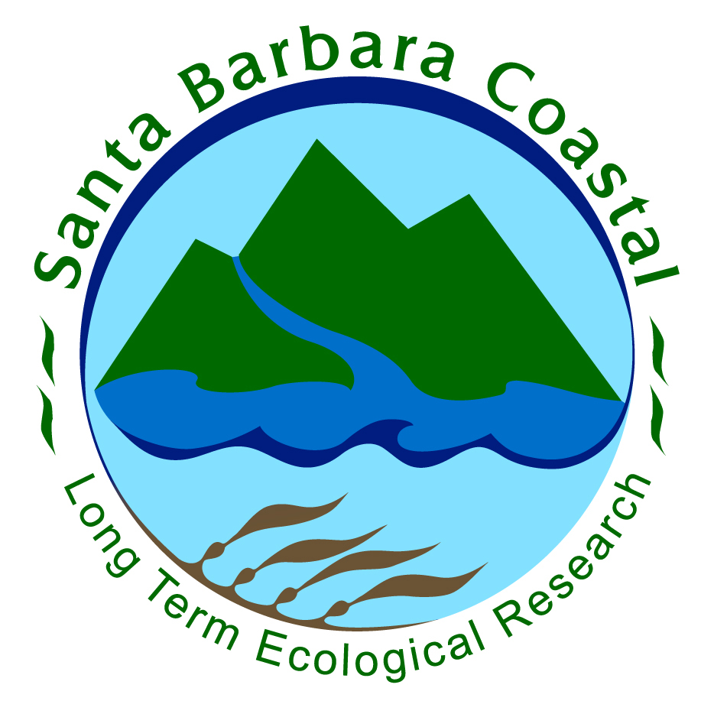

SBC LTER ANNUAL ALL SCIENTISTS MEETING
1-8 pm November 18, 2016
MSRB Auditorium

AGENDA

1:00 Welcome and overview of SBC LTER III research – Dan Reed
1:30 Status of ongoing thematic research campaigns
- Theme 1: Understanding and predicting kelp forest community dynamics across multiple temporal and spatial scales – Max Castorani
- Theme 2: Spatio-temporal patterns of nutrient fluxes as a function of hydrologic variability, land cover and fires in SBC LTER catchments – Rosana Aguilera Becker
- Theme 3: Identifying new sources of nitrogen to support giant kelp growth – Jason Smith
2:45 Poster introductions (1 min each)
3:15 Poster session and refreshments
4:30 Planning for SBC LTER IV – Group discussion led by Dan Reed
5:30 Social with libations
6:00 Dinner on the 2nd floor balcony

