Title: Global synthesis of the temperature sensitivity of leaf litter breakdown in streams and rivers
J. J. Follstad Shah^{1,2*}, J. S. Kominoski³, M. Ardón⁴, W. K. Dodds⁵, M. O. Gessner^{6,7}, N. A. Griffiths⁸, C.P. Hawkins², S.L. Johnson⁹, A. Lecerf¹⁰, C. J. LeRoy¹¹, D. W. P Manning¹², A. D. Rosemond¹³, R. L. Sinsabaugh¹⁴, C. M. Swan¹⁵, J. R. Webster¹⁶, L. H. Zeglin⁵
¹University of Utah, Environmental and Sustainability Studies / Department of Geography, Salt Lake City, UT 84112, ²Department of Watershed Sciences, Utah State University, Logan, UT 84322, USA, ³Department of Biological Sciences, Florida International University, Miami, FL 33199, USA, ⁴Department of Forestry and Environmental Resources, North Carolina State University, Raleigh, NC 27695, USA, ⁵Division of Biology, Kansas State University, Manhattan, KS 66506, USA, ⁶Department of Experimental Limnology, Leibniz-Institute of Freshwater Ecology and Inland Fisheries (IGB), 16775 Stechlin, Germany, ⁷Department of Ecology, Berlin Institute of Technology (TU Berlin), Ernst-Reuter-Platz 1, 10587 Berlin, Germany, ⁸Climate Change Science Institute and Environmental Sciences Division, Oak Ridge National Laboratory, Oak Ridge TN 37831, USA, ⁹Pacific Northwest Research Station, US Forest Service, Corvallis, OR 97331, USA, ¹⁰Université de Toulouse, UPS, INP, CNRS, EcoLab (Laboratoire d’Écologie Fonctionnelle et Environnement), 31062 Toulouse, France, ¹¹Environmental Studies Program, The Evergreen State College, Olympia, WA 98505, ¹²School of Environment and Natural Resources, Ohio State University, Columbus, OH 43210, USA, ¹³Odum School of Ecology, University of Georgia, Athens, GA 30602, USA, ¹⁴Department of Biology, University of New Mexico, Albuquerque, NM 87131, USA, ¹⁵Department of Geography and Environmental Systems, University of Maryland-Baltimore County, Baltimore, MD 21250, USA, ¹⁶Department of Biological Sciences, Virginia Polytechnic Institute and State University, Blacksburg, VA 24061, USA.
*Corresponding author: Jennifer J. Follstad Shah
E-mail: jennifer.shah@envst.utah.edu
Phone: +1 801 585-5730

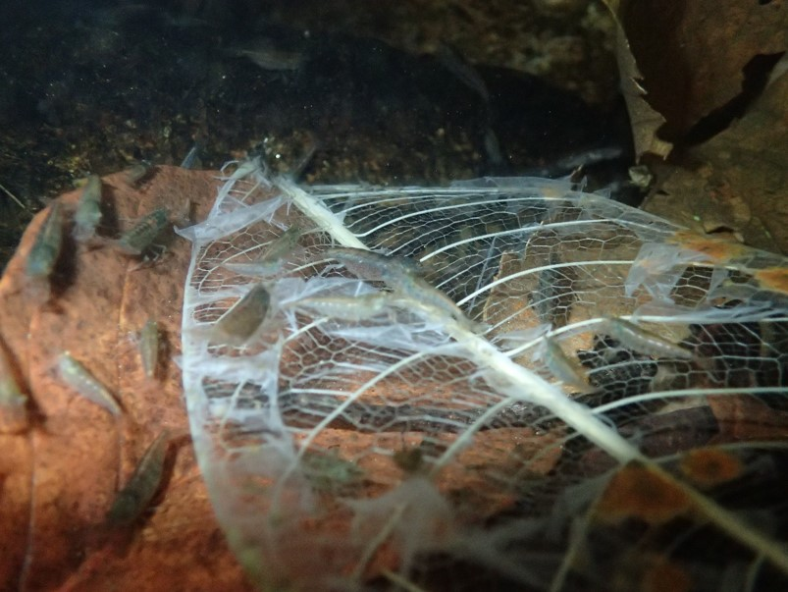
Photo credit: Walter Dodds

Warmer water enhances decomposition in streams and rivers, but it is unclear if more carbon will be emitted to the atmosphere or transported to the ocean with climate change. We assembled over 1000 records on leaf litter breakdown globally to assess how this process will change with elevated temperature. We found rates may increase half as much as expected should water temperature rise by 1-4 °C, with no change in the proportions of carbon converted to gas vs. smaller particles.

