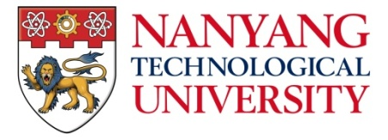

Smithsonian-NTU Programme Coordinator
Young and research-intensive, Nanyang Technological University in Singapore (NTU) is ranked 13th globally. It is also placed 1st amongst the world’s best young universities. In 2015 the newly established Asian School of the Environment (ASE) at NTU embarked on a long-term partnership with the Forest Global Earth Observatory programme of the Smithsonian Institution (ForestGEO) to capitalise on the strengths and dynamism of both institutions. Together, NTU and ForestGEO will collaborate on research, training and capacity development in forest science, and create a cosmopolitan hub for forest ecology in Asia.

ASE and ForestGEO invite applications for the position of Programme Coordinator for the ForestGEO Asia Program.

The position will oversee and coordinate ForestGEO activities in Asia, implement and guide future research directions, foster collaboration that encourages broad use of the regional network, conduct independent research related to the ecology of Asian forests, lead training and capacity strengthening activities for students and researchers associated with ASE and ForestGEO sites, seek external funding, and promote ForestGEO and ASE to diverse audiences.

The successful candidate will have a PhD in ecology or related field (including but not limited to population and community ecology, physiological ecology, ecosystem science, global change biology, and plant systematics and evolution), at least 5 years experience working on the forests of tropical Asia, and experience with data management and ecological analysis.

Application Procedure:
Interested candidates should submit a single PDF containing a summary of research accomplishments and interests, curriculum vitae, three significant reprints, and the names and contact information of three referees to Ase_humanresources@ntu.edu.sg. We regret that only shortlisted candidates will be notified. More information can be found at www.ase.ntu.edu.sg/careers and http://www.forestgeo.si.edu/ or by contacting Stuart Davies (daviess@si.edu).

Smithsonian is an equal opportunity and affirmative action employer and is committed to diversity in its workforce for all employees, interns, research associates, fellows, volunteers, and other individuals associated with the Smithsonian.

