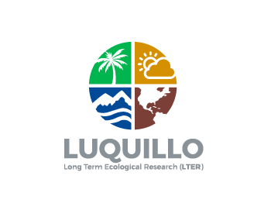
Move the SUN to the left side. Move Palm toright side

Make the mountains dark green with a blue sky background as it is now
Keep the “river” blue as it is now.

