**Mass Audubon’s Salt Marsh Science Project**

Education Coordinator: Liz Duff

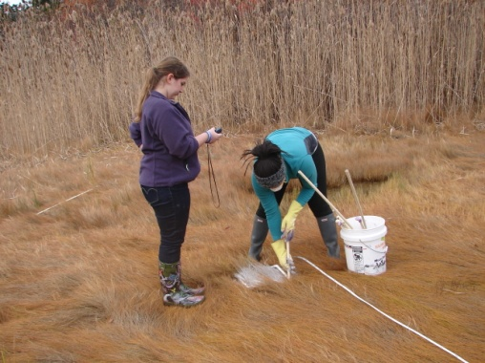

**Setting Marker Horizons**

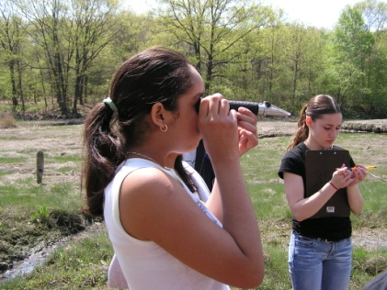

**Measuring**

**Salinity**

* **Field activities** with students included mapping the salt marsh distribution of invasive species such as *Phragmites australis*, and perennial pepperweed (*Lepidium latifolium*); quantifying species richness, and measuring salinity.
* **Investigate Sea Level Rise** with marker horizons.
* **Encourage wetland stewardship actions** such as pulling pepperweed, mapping areas vulnerable to sea level rise and reducing one’s carbon footprint.
* **Host an annual** **Coastal Science Conference** that brought together teachers and students from participating schools. Students shared their findings with each other and with scientists working on the marshes in the region.
* **Support teachers and students** by developing materials, training teachers, and participating in classroom and field activities.
* **Maintain** the Salt Marsh Science Project **data base and website.**

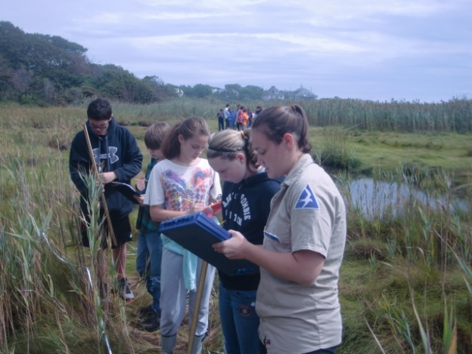

**Measuring biodiversity**

**and *Phragmites***

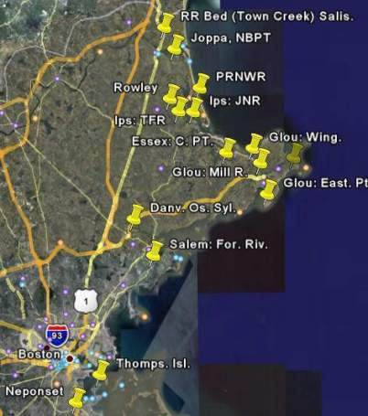

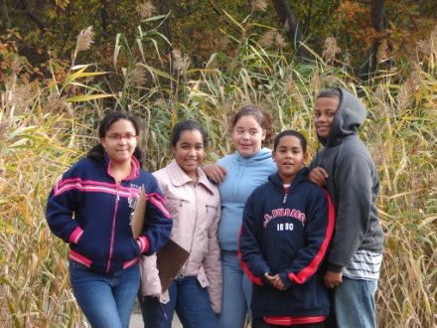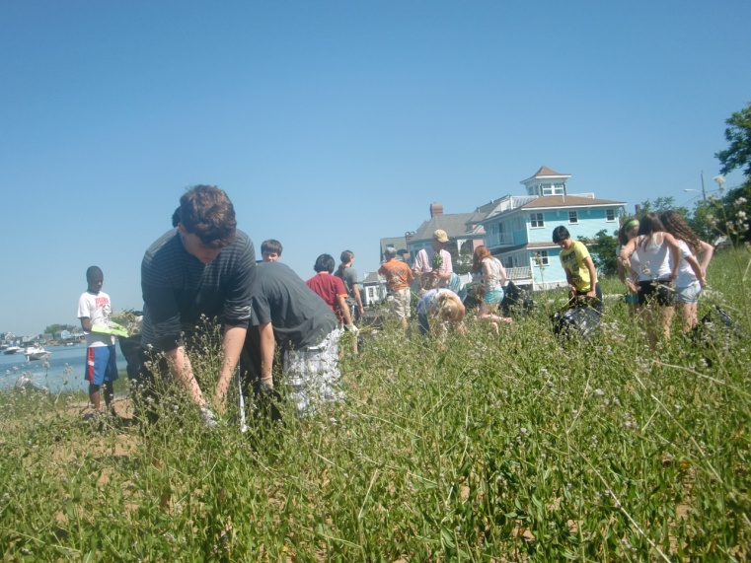

**Engaging Urban Students**

Study sites include the Plum Island Region and beyond.

**Inspiring Stewardship**

Measuring Salinity

Inspiring Stewardship