One of the challenges in communicating about climate change is the nearly incomprehensible scale on which the issue takes place. Wrapping ones head around a global problem and long-term data without a relatable local grounding is hard. Enter The Tempestry Project (tempestryproject.com), whose goal is to combine art and science to illustrate changes in climate over time scales that are meaningful to everyone; in essence, to scale down an enormous issue into artwork that is beautiful, meaningful and tangible while staying true to the data at its heart.

According to the founders: "A Tempestry is a wallhanging, or temperature tapestry, that represents the daily high temperature for a given year and location, with January at the bottom and December at the top – think of it like a bar graph. All Tempestries use the same yarn colors and temperature ranges, creating an immediately recognizable and globally comparable mosaic of shifting temperatures over time."

In 2018, The Tempestry Project created over 500 kits to illustrate climate data from across the country and around the world, introducing a new audience to long-term data. Erika Zambello, a contractor for the LTER communications office, says: "When you spend over an hour working on just one month of data, you gain an entire new understanding of temperature fluctuations in a given year." Erika, who writes the stories for the LTER Road Trip series, is coordinating a Tempestry for the National Parks Service. Volunteers sign up for a park that is important to them, purchase a custom kit ($158 for materials and instructions for two Tempestries) and knit Tempestries for 1916 - the year the NPS was established - and 2016.

We propose a similar initiative for the LTER network. Wouldn’t it be amazing to have a Tempestry that communicated temperature data from each site in the same years as the NPS Tempestry plus the additional data point of 1980, when the network was founded? We could build a rotating display that could travel to libraries or other community spaces around the network. Or you could find additional knitters to fill our your site’s year-by-year history for your own display.

If you are interested in recruiting participants in your site’s community, please let Caitlin (caitlin@umn.edu) and Erika (eaz26@cornell.edu) know. We can provide you with a form letter to ask for financial assistance from local Friends groups, environmental organizations, etc.

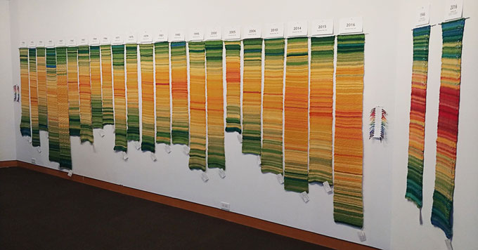

Tempestry Collection at Yale Climate Connections

