Grand challenges in biodiversity-ecosystem functioning research in the era of science-policy platforms require explicit consideration of feedbacks

Mary I. O’Connor^{1,2}, Akira S. Mori³, Andrew Gonzalez⁴, Laura E. Dee⁵, Michel Loreau⁶, Meghan Avolio⁷, Jarrett E. K. Byrnes⁸, William Cheung^{2, 9}, Jane Cowles¹⁰, Adam T. Clark¹¹, Yann Hautier¹², Andrew Hector¹³, Kimberly Komatsu¹⁴, Tim Newbold¹⁵, Charlotte L. Outhwaite¹⁵, Peter B. Reich¹⁶, Eric Seabloom¹⁰, Laura Williams¹⁶, Alexandra Wright¹⁸, Forest Isbell¹⁰.

- Department of Zoology, University of British Columbia, Vancouver, Canada
- Biodiversity Research Centre, University of British Columbia, Vancouver, Canada
- Graduate School of Environment and Information Sciences, Yokohama National University, Yokohama, Japan
- Department of Biology, McGill University, Montreal, QC, Canada
- Department of Ecology and Evolutionary Biology, University of Colorado at Boulder, Boulder, CO
- Theoretical and Empirical Ecology Station, CNRS, Moulis, France
- Department of Earth and Planetary Sciences, Johns Hopkins University, Baltimore, MD 21218.
- College of Science and Mathematics, University of Massachusetts – Boston, Boston, MA
- Institute for the Oceans and Fisheries, University of British Columbia, Vancouver, Canada
- Department of Ecology, Evolution and Behavior, University of Minnesota, St. Paul, MN, USA
- Institute of Biology, University of Graz, Holteigasse 6, 8010 Austria
- Ecology and Biodiversity Group, Department of Biology, Utrecht University, Padualaan 8, 3584 CH Utrecht, The Netherlands.
- Department of Plant Sciences, University of Oxford, Oxford, UK
- Smithsonian Environmental Research Center, Edgewater, MD USA
- Centre for Biodiversity and Environment Research, Department of Genetics, Evolution and Environment, University College London, London, UK
- Department of Forest Resources, University of Minnesota, St. Paul, MN 55108 USA
- Hawkesbury Institute for the Environment, Western Sydney University, Penrith, NSW 2753, Australia
- Biological Sciences Department, California State University Los Angeles, 5151 State University Dr., Los Angeles, CA, USA

Abstract:

Feedbacks are an essential feature of resilient socio-economic systems, yet the feedbacks between biodiversity, ecosystem services and human wellbeing are not fully accounted for in global policy efforts that consider future scenarios for human activities and their consequences for nature. Failure to integrate feedbacks in our knowledge frameworks exacerbates uncertainty in future projections and potentially prevents us from realizing the full benefits of actions we can take to enhance sustainability. We identify six scientific research challenges that, if addressed, could allow future policy, conservation and monitoring efforts to quantitatively account for ecosystem and societal consequences of biodiversity change. Placing feedbacks prominently in our frameworks would lead to i) coordinated observation of biodiversity change, ecosystem functions and human actions, ii) joint experiment and observation programs, iii) more effective use of emerging technologies in biodiversity science and policy, iv) and a more inclusive and integrated global community of biodiversity observers. To meet these challenges, we outline a 5-point action plan for collaboration and connection among scientists and policy-makers that emphasizes diversity, inclusion, and open access. Efforts to protect biodiversity require the best possible scientific understanding of human activities, biodiversity trends, ecosystem functions, and - critically - the feedbacks among them.

I. Dynamic feedbacks are causes and consequences of biodiversity change
Increasing recognition of irreversible biodiversity change and unsustainable ecosystem exploitation has spurred unprecedented collaboration among scientists and policymakers worldwide to mitigate these ecological crises (1–4). Biodiversity is in crisis as a result of habitat loss, overharvesting and other pressures associated with humanity’s accelerated use of natural resources (2,5–7). The diversity of life – from genes to social-ecological systems - plays a major role as both a driver of ecosystem dynamics throughout the biosphere and a response to changes in ecosystem processes; higher biodiversity can enhance ecosystem functioning (8,9) and ‘nature’s contributions to people’ (Glossary in Box 1), while also responding to human activities such as cultivation or harvesting. Biodiversity, its responses to human activities, and the benefits it can provide to human wellbeing are now at the center of global science-policy initiatives such as the Intergovernmental Panel on Biodiversity and Ecosystem Services (IPBES) and the Convention on Biodiversity (CBD) (10).

The science underpinning these major initiatives has clearly demonstrated direct effects of biodiversity on ecosystem functioning and human wellbeing (B-E-H) (Figure 1), as well as dynamic feedbacks (Section II) that influence how B-E-H system components change over time. Direct effects include the positive effect of species diversity on productivity and nutrient dynamics in plant and animal systems (8,11,12), increased productivity and food quality benefitting humans through an ecosystem service such as food provision (9,13–15), and food management systems that facilitate biodiversity (16,17)(Figure 1). Direct effects also include the human actors benefiting from nature, while also engaging in activities that benefit or harm biodiversity. Direct effects alone cannot tell the full story; system dynamics commonly feature feedbacks (Figure 1, Figure 2), and the biosphere is a system comprising the diversity of life on earth, human systems and ecosystems.

The next generation of biodiversity scholarship will expand the scale and scope of this topic to more effectively understand feedbacks as essential features of any focus on biodiversity and how it changes in relation to human activities and ecosystem functioning. This knowledge will better inform policy platforms and actions taken in compliance such as monitoring biodiversity. Here, we consider biodiversity, ecosystem functioning and humanity as components of a system, and in doing so, we highlight the central role that feedbacks play in sustaining dynamic relationships among these components (Section II). We do this because feedback is a familiar concept, yet it has been overlooked in most scientific work assessing the links between biodiversity and ecosystem functioning, and thus is missing from our understanding of the full relationships between people and biodiversity. Next, we briefly review how current leading policy platforms consider the role of feedbacks and highlight opportunities for strengthening consideration of feedbacks (Section III). We then identify key scientific knowledge gaps (Section IV) that we suggest limit the full uptake of scientific understanding into policy platforms and deserve organized and collaborative investment for rapid progress. Finally, we outline an agenda for collaborative action (Section V) to meet these challenges to support policy-relevant science in a changing world, as our understanding of that world also changes.

II. Feedbacks are essential features of biodiversity – ecosystem functioning – human relationships
Biodiversity and its relationships to ecosystem functioning and human wellbeing depend on feedbacks within and between these system components (Figure 1; Figure 2) (18–20). The concept of feedback is often used to describe specific dynamic interactions that are considered real and observable in human ecological systems. The feedback concept is also used to refer to interaction networks (21) or dynamics of a complex system that amplify or dampen an outside signal or effect. Additionally, the concept of feedback can be used more loosely as a communication tool, for example, when a species’ ‘final descent into extinction’ reflects synergistic effects of multiple stressors, the synergy may be referred to as involving a feedback (22). Feedbacks between biotic and abiotic processes driving the global carbon cycle have received great attention in climate science and policy because they cause systems to change in non-intuitive ways over time (23,24). Additionally, feedbacks between human and ecological subsystems have become an important area of interdisciplinary research and for guiding discourse (25–27). These research programs all contribute to the solution we are addressing here – which is to better understand feedbacks specifically in the B-E-H system as a whole (28), and how best to apply this understanding to broad scale policy, communication and knowledge integration programs.

A simple definition of feedback is when one part of a system affects another part of that system that in turn affects the first part; in other words, a system output affects the input of the same system. This definition is consistent with systems biology, recognizing feedback as a control mechanism in complex systems. Negative feedbacks (Figure 2A) are self-dampening and stabilizing, and can buffer systems against change (29,30). In contrast, positive feedbacks are self-reinforcing and can be destabilizing (31) (Figure 2B). To illustrate, modeling feedbacks as opposed to direct effects involves approaches such as equations that relate the behavior over time of a system to the state of that same system in some way. It is this self-dependent relationship that distinguishes models with dynamic feedbacks from models that include direct and indirect effects but do not relate these in feedbacks (Figure 2).

Feedbacks explain change and stability in systems involving biodiversity, ecosystem functioning and human well-being. Among the processes that maintain biodiversity, feedbacks determine stability and future trajectories of population, community and ecosystem dynamics (32,33), from shallow lakes (34) to tropical rainforests (35) to coral reefs (36). One of the most pervasive feedbacks in ecological systems is density dependence of population dynamics. Density dependence is a feedback in which population density at one time influences population growth at a future time, which in turn influences future population density (Figure 2). In diverse systems, stronger density dependence within species than among species is one of the primary explanations for the persistence of biodiversity in nature and for the positive relationship between biodiversity and ecosystem services (3,37,38)(Figure 2C). Negative (dampening) density-dependent feedbacks of predation, disease and pathogens on species’ performance cause diverse systems to maintain diversity and ecosystem functions over time more than less diverse systems (20,39–41) (though these ecological interactions can also be involved in positive feedbacks). Density-dependent processes are at the heart of compensatory dynamics in which a decline in density of a competitive dominant allows competitors to increase in abundance and maintain ecosystem functions in a negative feedback (3,38,42). In some cases, we can study the dynamics of part of the system – for example, we isolate feedbacks that maintain diversity when we study compensatory dynamics – but to fully understand the problems we now face, we have to continue the research process by expanding our focus from the dynamics of a subsystem to the more complex B-E-H systems.

There are many examples of change that we now understand to depend on feedbacks between biodiversity, ecosystem processes and human activities. These include feedbacks that lead to the conversion of grassland to desert following disturbances or biodiversity loss (32), and the conversion of kelp forests to barrens in coastal oceans (43). Another example is that of pollinator diversity and plant diversity (44,45)(Figure 1E). Pollinator functional diversity can increase pollination and plant seed production (46,47). Higher pollinator diversity may enhance plant diversity when there are positive interactions between different specialized plant and pollinator species, through niche complementarity (different pollinators pollinate different plants) as well as changes in pollinator behavior when more pollinators are present (48,49). This creates a positive feedback: pollinator diversity affects plant diversity which can in turn feedback to enhance and sustain pollinator diversity (Figure 1E). Further, humans benefit when the plants are of cultural or agricultural value. Some agricultural practices, land use change and pollution have dramatically reduced pollinator abundance and diversity (50,51), potentially contributing to loss of value in crop yields. Negative effects of human activities on pollinator diversity and the recognition of the feedback of human activities to human benefits through crop pollination have motivated conservation and management actions that focus not only on reducing pollution but also on restoring diversity in plant-pollinator-human systems (52). The inclusion of conservation activities focused on pollinator diversity creates a feedback involving humans, pollinators and plant diversity (Figure 1E).

III. Feedbacks have been under-emphasized in major science-based policy platforms
Major science-based policy platforms guide decisions about a broad range of actions that impact biodiversity change, including setting targets for sustainability (UN Sustainable Development Goals, SDGs) and biodiversity trends and investing in monitoring programs as guided by The Group on Earth Observations Biodiversity Observation Network (GEO BON). The IPBES framework (2,10) provides the broader community a system for understanding how biodiversity, inclusive of humanity and human diversity (Box 1), are related to a sustainable biosphere (53). This framework is offered with the purpose of aligning assessments of change and knowledge development in biological and social sciences with the policy challenges of the coming decades (53,54). These challenges include state-level investments in biodiversity observation and conservation (55,56), as well as integration of policies to jointly mitigate climate change and biodiversity change (57–59), and to manage food systems for nature positive outcomes and sustainable food provision (60).

The IPBES platform also channels and motivates scholarship and scientific research to fill gaps and improve methods for modeling scenarios. It relies on synthesis of scientific evidence for the causes and consequences of biodiversity change. The evidence is combined with scientific models to project and forecast future scenarios for biodiversity change and human activities (61). There is little mention of full feedback cycles between biodiversity and ecosystem functioning (e.g., Figure 1A) in the summary of models used to generate projections and scenarios for the most recent IPBES report. The few existing examples are in the integrated assessment models involving social and economic systems coupled with natural systems (61). The assessment report indicates that feedbacks are identified as an outcome of integrated system models, rather than an architectural feature (61). The IPBES approach to scenarios does include qualitative modeling methods that can capture feedbacks, though these methods are largely restricted to smaller-scale social-ecological system studies. For example, subsets of interactions between fish population dynamics and fishing behavior have been represented in quantitative fisheries modelling (62). However, a major gap exists in the integration between different types of interactions in order to more comprehensively characterize the major feedbacks between (or within) ecosystems and fisheries.

Deepening our understanding of feedbacks is identified as a research challenge, and the IPBES methods assessment report notes that ‘Failure to consider such [feedback] dynamics can potentially render scenario analysis incomplete, inconsistent or inaccurate’. IBPES authors and ecosystem modelers also highlight the risks associated with including feedbacks based on wrong or incomplete understanding. It is recognized that feedbacks need to be included more, and that knowledge gaps - both scientific and in the general understanding and application of science – are a barrier. As we move to consider feedbacks more, it is important to recognize that there are many ways to do this – quantitative modeling is one way, but is not always the most feasible or even most accurate way. Heuristic consideration of feedbacks as illustrated in the pollinator example (Figure 1E) is another way to incorporate the idea that systems are self-referential and self-dependent, and that humans are part of the system in which we are interested. A wide range of modeling and visualization tools exist to support consideration of feedbacks.

IV. Key knowledge gaps that present grand challenges for biodiversity research
Getting feedbacks right in our models and how we interpret them to make forecasts and assessments is critical. Our survey of feedbacks in biodiversity-ecosystem functioning science and related policy frameworks reveals eight knowledge gaps that emerge when we consider the B-E-H system as a whole system, rather than take previously prevalent perspectives that emphasize two of the three components – Biodiversity and Ecosystem Function (BEF) that tends to consider human activities as outside the system, or socioecological systems (SES) in which biodiversity and functioning are lumped into one component. Filling these knowledge gaps requires targeting feedbacks as scientific research goals, and considering how assessments and policies can best reflect this knowledge development and subsequent gain. We suggest that these challenges might be used to prioritize major investment to expand the biodiversity-ecosystem functioning paradigm and enhance our knowledge frameworks to support biodiversity policies and to realize sustainability goals (Agenda for Action, Section V).

- We cannot robustly relate current or recent temporal trends in biodiversity to likely future trajectories of biodiversity change in most cases. As we have noted above, future biodiversity, and diversity’s contribution to ecosystem services, may not be accurately predicted by extrapolating a historical trend in biodiversity forward in time because of feedbacks among biodiversity, ecosystem function and human activities (33,61,63,64). Consideration of feedbacks highlights that human activities and ecosystem functioning are part of changing biodiversity in the system, and forces us to reframe this question such that we cannot only examine biodiversity trajectories. When feedbacks are at play, trajectories of a system observed over a short time span are not necessarily indicative of longer-term patterns (65–67). To estimate long-term behavior of a B-E-H system in scenarios that might be used to guide decisions, the dynamics – and in particular, feedbacks such as how biodiversity change and its causes can influence future biodiversity – need to be considered (21,68).

- We do not understand the B-E-H system well enough to relate observed recent trends in biodiversity to likely future trends in biodiversity, ecosystem function and human wellbeing. Dynamics of one part of the system (for example, diversity) depend on other parts of the system (humans, ecosystem functions), and vice versa. Because feedbacks characterize how biodiversity, ecosystem functioning and human activities change together over time, projected future trajectories or scenarios of diversity, ecosystem functioning or human wellbeing require consideration of all three components. Similarly, observations of ecosystem functions such as production, carbon storage or nutrient uptake in the absence of concurrent biodiversity estimates are difficult to project forward with confidence, given the inability to project changes in the diversity / ecosystem functioning feedbacks (69). One pervasive consequence of this knowledge gap is the persistent decoupling of biodiversity and functioning in assessment and monitoring programs; most of the biodiversity observations being assembled for biodiversity change assessments (e.g., BioTIME, PREDICTS, GEO BON) do not systematically include accompanying measures of ecosystem processes or human activities. Though GEO BON is moving in this direction with essential ecosystem variables, such an advance must be made in the context of statistical approaches that can allow detection and attribution of joint changes in biodiversity, ecosystem functioning and human wellbeing.

- Trends in B-E-H components depend on scale, yet we still do not understand exactly how, and what feedbacks play in determining scale-dependence. Trends observed at one scale do not necessarily predict trends at higher or lower spatial resolutions (70) levels of organization, and this gap is a major barrier to synthesizing observations across studies and programs to infer biodiversity change (71). We require new theory to guide experimental tests and observation programs that allow us to more deeply understand feedbacks between diversity change and ecosystem functioning, and how these are linked in coupled human-natural systems across scales of space, time and organization (71) (Figure 3). For example, we do not have a robust model defining how changes in biodiversity at large scales (e.g., global or continental) interact with changes at fine spatial scales (e.g., locally operating processes such as disturbance, invasion or restoration) to influence biodiversity and ecosystem functioning. Such theory and experimental work would be explicit about temporal patterns in biodiversity and ecosystem functioning, spatial and temporal variation, and would identify links between feedbacks involving ecosystem functioning and multiple dimensions of diversity, and the role that human systems play in these biodiversity-ecosystem functioning linkages.

- Experimental tests for direct BEF effects have omitted feedbacks. The majority of experimental tests of the relationship between biodiversity and ecosystem functioning conducted in the last two decades has employed an experimental design that intentionally disrupts potential feedbacks – for example, by weeding out species that colonize (72) or by replacing species that are lost (73) over the course of the experiment to maintain diversity treatments. Though this approach does clearly isolate the effect biodiversity can have on ecosystem functions (straight arrows in Figure 1A), in doing so these procedures prevent feedbacks between diversity and ecosystem functioning (e.g., Figure 2C) from playing out over time. Consequently, the hundreds of experiments frequently reviewed and synthesized as strong evidence for direct effects of diversity on ecosystem functioning (8,74) cannot be used to demonstrate consequences of the feedbacks between diversity and functioning because each system studied was manipulated to prevent the self-dependent feedbacks (Figure 2) from occurring.

- Human-biodiversity feedbacks are still not well understood, allowing to persist a perception within the western science framing that people affect biodiversity but that there is no feedback from biodiversity to people (2,26,28,60,75). The current IPBES framework acknowledges this knowledge gap: in the assessment of methods, one of the high-level messages (Key Finding 3.3) is that scenarios and models ‘need to be better linked in order to improve understanding and explanation of important relationships and feedbacks between components of coupled social-ecological systems” (61). The high-level treatment of B-E-H feedbacks (implicit in the coupled socio-ecological systems) in the IPBES and its methods assessment suggests that recognition of the importance of feedbacks is not the only issue, but that scientific understanding of these feedbacks and how to model them at ecologically relevant scales are barriers to a fuller treatment of feedbacks in biodiversity scenarios. The challenge we face is therefore

- to integrate the multiple human (behavioral, demographic, social, political, economic, institutional) components of the B-E-H system in ways that reflect the dependence of human wellbeing on biodiversity as well as the effects of humans on biodiversity (26,76). Meeting this challenge requires transdisciplinary scholarship to identify the dominant feedbacks and the feedbacks of particular interest to stakeholders, as well as to develop approaches to model these feedbacks and to communicate their effects on system projections and scenarios.

- Develop an operational understanding of how different dimensions of biodiversity are involved in feedbacks over time. Much of our current and future estimates of biodiversity and its change will be based on observations of some dimension of biodiversity as defined in conventional scientific concepts: alleles, genes, traits, species (or operational taxonomic units, OTU), and models of phylogenies. Not only do we still require great investment (Section VI) in organized biodiversity sampling and monitoring (77), we also lack the scientific knowledge to relate changes in observed diversity at different levels of biological organization (genes vs species; Figure 3) to changes in ecosystem functioning, and feedbacks between biodiversity and ecosystem functioning. One key element of BEF feedbacks is trait expression, which links biodiversity contained in genes and genomes to biodiversity of traits, and as such BEF feedbacks also play a role in which genes and genomes persist in communities (78). We require new theory, models and empirical understanding of how the aspects of diversity that are realized through the expression of traits is related to the diversity present in genes and alleles, and why patterns of trait expression vary in space and time in the context of and as consequences of ecosystem functioning and human actions.

7) Understanding how changing ecosystem services over time depend on ecosystem functions and biodiversity-functioning feedbacks. Direct, one-way interactions between biodiversity and ecosystem functions, and ecosystem functions and services, are well-established for several services (e.g., 79). It is also well-recognized that many ecosystem services depend on the presence of specific species or functional groups (53,80), thus implicating biodiversity-ecosystem functioning feedbacks as broadly defined (Box 1: Glossary). However, the strengths of interactions between biodiversity and services remains less established for many services, especially with respect to the role of biodiversity-ecosystem functioning feedbacks as defined more strictly to be additional to the contributions of particular species (Box 1: Glossary) (79,80). It remains unclear how ecosystem functions, or related sets of functions (sometimes called ‘multifunctionality), confer ecosystem services that are relevant for human wellbeing (81,82). For example, although some services likely map directly to commonly studied functions - e.g. carbon sequestration - for others, the link is less straightforward - e.g. existence value of conservation land or of particular species (83). Furthermore, the dependence of services upon feedbacks between biodiversity and ecosystem functions is not well characterized.

8) Develop theory and workflows that explicitly relate information from emerging technologies to knowledge that can be used to deepen our understanding of feedbacks. Observation of nature is at the core of the research approaches that will allow us to meet these challenges. Technological tools for observing biodiversity allow high throughput and remote sensing of dimensions of biodiversity and ecosystem functioning at the finest levels of biological organization (viruses, genes and microbes) as well as some measures of ecosystem functions (84–88). As vast amounts of observational data become available, we face the challenges of understanding how to interpret these observations in the context of dynamic feedbacks. Uncertainty in biodiversity observations and coupled measures of ecosystem functioning also present a barrier to robustly combining observations into models of change to understand change across scales. Furthermore, feedbacks are difficult to detect from most observational datasets because they require coordinated observations of several facets of a system (e.g., biodiversity, an ecosystem function such as biomass production, human use of the biomass, plus any human – biodiversity interactions), and in nearly all cases, these coupled measurements are not made. Many observations of biodiversity cannot be robustly integrated into models of change over time without accompanying theory and empirical evidence for relationships between observations and the system components they represent.

V. Agenda for action.
We have outlined five key knowledge gaps and six associated challenges in B-E-H scientific knowledge that limit our current capacity to assess changes to the biosphere. Resolving these knowledge gaps will require investment in scientific research programs worldwide to employ diverse, interdisciplinary and even transdisciplinary approaches in the field, lab, and in silico. As we deepen our scientific understanding of feedbacks that drive biodiversity change and its consequences, we still face the challenge of relating this complex information to accessible policy information and social messaging. Outside specialist research communities, B-E-H feedbacks and their consequences are not well represented in conceptual diagrams and models used by policy experts and decision makers to understand biodiversity change and its likely consequences over time. Greater emphasis on this representation can help minimize overlooking this important concept when identifying priorities for biodiversity observation or multifaceted conservation opportunities. Further, many knowledge systems beyond science – such as traditional ecological knowledge systems - include knowledge of feedbacks (26,76,89), and therefore an emphasis on feedbacks may provide another scaffold to integrate biodiversity understanding across diverse forms of knowledge. We suggest that consideration of potential feedbacks in B-E-H systems can guide decisions about how to invest observation effort, about prioritization of conservation actions to vulnerable or stable systems, and in optimal workflows to convert knowledge into action to protect future biodiversity.
Here, we outline five ‘action items’ for implementing the research agenda to maximize benefits to the science-policy community. This agenda is intended to guide knowledge production, but does not outline the full process of informing policy; that important process needs additional consideration beyond the scope of this article.

Collaborate and connect
We must convene and support collaborations and knowledge development that reflects all the ways people know and interact with biodiversity. The action item required here is to come together in workshops, discussions and teams to identify priorities at local, regional and global scales that reflect the depth and diversity of how humans and biodiversity are co-dependent. We must take the time to listen and learn from each other, and build from these conversations to the observation and solutions programs we call for. Scientists, policy makers, industries and communities worldwide must collaborate all stages of biodiversity change assessments – and at all stages of our proposed action agenda. People serving as observers, knowledge keepers and knowledge users, as ecosystem service beneficiaries and decision makers play critical roles in the actual B-E-H feedback cycles, because assessment and management are part of the cycles! Scientific and science-policy collaborations in biodiversity research should strive for cultural, geographic, political and ethnic diversity among researchers and within research projects (90). We can build on existing science-community partnerships and extending these into biodiversity observation and assessment networks (91). Doing so will result in an inclusion of a broader range of knowledge systems and perceptions of human-biodiversity interactions (90), benefitting an understanding of feedbacks that is both globally and locally relevant worldwide.

Build and sustain multi-scale models to develop and revise scenarios of biosphere change.
Though models exist to produce biodiversity scenarios for the future (3,92), we must double down on our capital and personnel investments in these models to not only simulate changes in biodiversity but also the feedbacks between biodiversity change and changes in human activities and ecosystem functions. To serve the needs of science and society, we must be able to update these models as new observations become available, and to produce scenarios at a range of scales relevant to human decisions – from the scale of a plot of land to that of a country or the globe. Further, we must be modeling biodiversity in the context of the full system, which may be achieved by integrating biodiversity models with other models such as climate models or integrated assessment models ((93,94)). Models provide the visualizations of biodiversity change that can help people explore the consequences of various actions. These models must be developed and improved in conjunction with the increased effort in biodiversity observatories, advancing statistical procedures for robustly detecting and attributing change, and within the context of the kinds of decisions that will need to be made. Such an effort is large-scale, complex and will involve partnerships across institutions, public and private sector, and across nations and cultures.

Build and sustain national and global observatories for temporal change in biodiversity, ecosystem functioning and human activities.
Integrated observations must be made at different spatial scales with worldwide coverage (84), going beyond the ad hoc approaches to sampling of biodiversity throughout the world that has produced a set of observations of diversity that is highly biased to developed countries and terrestrial habitats (3,71,95). To meet the research challenges we outline above, observation programs based on international collaborations and local investment must jointly and simultaneously observe biodiversity change, ecosystem functioning change and human activities – such an integrated observation system goes beyond existing infrastructure for most places (Gonzalez et al One Earth)(55). New statistical approaches must be developed to understand causation in the complex systems we are observing (96). Further, biodiversity change observatories need to be comprehensive in their inclusion of areas and biomes on our planet, breaking the historical pattern of emphasis on developed countries and the socially dominant communities within them (55,97). New approaches, such as that proposed by Kühl et al (2020)(91), must emphasize community involvement and data collection supported by and integrated within a broader context of biodiversity assessment. To succeed, these require investment and action as called for here and by others (91,97,98).

Experimentally and iteratively test the models and re-evaluate our understanding.
To understand feedbacks, observational programs (Action 3) should be guided by theory that includes feedbacks, and coupled with experimental programs to understand feedbacks. As with observatories, the experimental and modelling programs must be run by collaborations of scientists, modelers and end users from a broad range of biomes, countries and cultural backgrounds, specifically including indigenous and local peoples from the global north and south. This action item is to increase investment in experimental programs that help to fill specific gaps in our understanding of biodiversity change, and to prioritize those programs led by multi-sector and multi-disciplinary research and data user teams.

Identify and support a sustained organizational structure.
A leadership team must assemble, must be able to draw on existing scientific knowledge and work with the research community to develop research programs. The leadership team must facilitate diversity and comprehensive inclusion of nature and people in the research programs and associated policy development programs, can promote the research agenda to potential users and supporters, can lead public engagement activities, and can ensure fully open science practices and data archiving so the findings are available to everyone in the world. The structure of the leadership team should be consistent with current values, and consider collaborative networks and other social structures in its design.

Along the way, the research community will need to confront additional logistical challenges that currently limit rapid scientific advances. These have received attention elsewhere, and resolving these challenges is critical the success of the agenda we have outlined here. These include i) the current lack of open science and the fact that data for biodiversity and ecosystem functioning from many places is not curated or made available in a central database (98), ii) limited technology integration such that observations from different methods are not spatially coordinated (55), and ii) the clear need for more balanced engagement from the global community (90).

VI. Conclusion
Feedbacks between human wellbeing, biodiversity and ecosystem functioning have been appreciated and understood for millennia. Yet, only in recent decades has scientific progress led to recognition of the importance of feedbacks among biodiversity, functioning and people across scales. Despite this recognition, and major progress with models, experiments and observations, major challenges remain to integrate this knowledge with new capabilities to meet the policy challenges of the coming decades. As major policy-guiding scientific assessments grow in importance, it is essential to keep striving for the scientific advances, and in particular theoretical advances, that will foster integration of state-of-the-art scientific understanding with international and local policy objectives. There is no substitute for knowledge of feedbacks. The effects of feedbacks over time cannot be approximated by static representations of direct effects (63). Many authors have noted that without a fuller scientific understanding of feedbacks that link biodiversity change, ecosystem functioning and human wellbeing, we risk making decisions based on modeled futures that do not capture the full range of likely possibilities (21,64,76,99,100). We cannot afford this just when we need science urgently to guide our planning for the future. By investing in science and supporting collaborative and interdisciplinary partnerships (101) we can realize the fullest potential of a collective knowledge system to project possible futures and act on our understanding of those projects in the best possible way for our planet.

Acknowledgments
We acknowledge support from the Long-Term Ecological Research (LTER) Network Communications Office and US National Science Foundation (NSF) DEB-1545288. We are grateful to Dr. Julián Idrobo and Dr. Matthew Whalen for thoughtful and constructive feedback on a draft of this manuscript. This research was supported by the US National Science Foundation (NSF) Long-Term Ecological Research (LTER) grants DEB-0620652, DEB-1234162, and DEB-1831944, Long-Term Research in Environmental Biology (LTREB) grants DEB-1242531 and DEB-1753859, and Biological Integration Institutes grant NSF-DBI-2021898. ML was supported by the TULIP Laboratory of Excellence (ANR-10-LABX-41).

Box 1: Glossary

Biodiversity: variety of life. We use the concept to include people in the living earth system; biodiversity is measured at many scales and in many ways, from genetic diversity to functional diversity to behavioral or cultural diversity.
Feedback: modification or control of a process by the results or effects of the same process.
Ecosystems: joint biotic/abiotic systems of life, characterized by dynamic stocks and fluxes of energy, materials and information and their feedbacks.
Biodiversity-ecosystem functioning (BEF) relationships: refers to the relationship between diversity per se and the magnitude and stability of an ecosystem functions. BEF refers to the role diversity plays in ecosystem functioning that is over and above the importance of total abundance, biomass or composition of the biological assemblage (102).
Ecosystem functioning: the processes of energy flow (e.g., primary production), material cycling (e.g., carbon cycling) and information processing (e.g., evolution) carried out by living systems. Functions are understood to reflect interaction networks involving multiple genetic and functional elements of biodiversity, and include stocks and pools of biomass, elements and energy forms.

Ecosystem services: the value of ecosystem functions to people (103), and originally, defined as ecosystem-based goods and services for human well-being (104). Although different opinions exist such as that ecosystem services could be viewed as "rights-based approaches to biodiversity conservation and sustainable use" (54), it is important to emphasize that the value can be assessed in a variety of ways, from economic values to cultural values, in intrinsic, instrumental or relational systems (104–106).
Natures contributions to people (NCP): a pluralistic view for the value of ecosystems and ecosystem functioning to people (105,106). Peterson et al. (106) expect the view to encourage a recognition of pluralism and the need for a richer process of articulation, translation, and discussion among many different perspectives on people’s relationship with nature. NCP can be inclusive of the concept of ecosystem services, and is moving toward a perspective that integrates humans as a dynamic part of the whole system.

References

1. Ceballos G, Ehrlich PR, Dirzo R. Biological annihilation via the ongoing sixth mass extinction signaled by vertebrate population losses and declines. Proc Natl Acad Sci. 2017 Jul;114(30):E6089–96.
2. Diaz S, Settele J, Brondizio E, Ngo HT, Gueze M, Agard J, et al. Summary for policymakers of the global assessment report on biodiversity and ecosystem services of the Intergovernmental Science-Policy Platform on Biodiversity and Ecosystem Services. 2019 May.
3. Loreau M. The Challenges of Biodiversity Science. Kinne O, editor. Vol. 17. Oldendorf/Luhe, Germany: International Ecology Institute; 2010. 120 pp.
4. Watson RT, Zakri AH. Ecosystems and Human Well-Being [Internet]. 2005 May p. 266 pp. Available from: https://www.millenniumassessment.org/documents/document.356.aspx.pdf
5. Maxwell S, Fuller R, Brooks T, Watson J. Biodiversity: The ravages of guns, nets and bulldozers. Nature. 2016;536(7615):143–5.
6. McCauley DJ, Pinsky ML, Palumbi SR, Estes JA, Joyce FH, Warner RR. Marine defaunation: Animal loss in the global ocean. Science. 2015 Jan 16;347(6219):1255641–1255641.
7. Newbold T, Hudson LN, Hill SLL, Contu S, Lysenko I, Senior RA, et al. Global effects of land use on local terrestrial biodiversity. Nature. 2015 Apr;520(7545):45–50.
8. Cardinale BJ, Matulich KL, Hooper DU, Byrnes JE, Duffy E, Gamfeldt L, et al. The functional role of producer diversity in ecosystems. Am J Bot. 2011 Mar;98(3):572–92.
9. Isbell F, Gonzalez A, Loreau M, Cowles J, Díaz S, Hector A, et al. Linking the influence and dependence of people on biodiversity across scales. Nature. 2017 May;546(7656):65–72.
10. Díaz S, Demissew S, Carabias J, Joly C, Lonsdale M, Ash N, et al. The IPBES Conceptual Framework — connecting nature and people. Curr Opin Environ Sustain. 2015 Jun;14(C):1–16.
11. Duffy JE, Richardson JP, Canuel EA. Grazer diversity effects on ecosystem functioning in seagrass beds. Ecol Lett. 2003;6:637–45.
12. Tilman D, Reich PB, Isbell F. Biodiversity impacts ecosystem productivity as much as resources, disturbance, or herbivory. Proc Natl Acad Sci U S A. 2012 Jun 26;109(26):10394–7.
13. Bernhardt JR, O’Connor MI. Aquatic biodiversity enhances nutritional benefits to humans. Proc Natl Acad Sci USA. 2021;
14. Frison AE, Cherfas J, Hodgkin T. Agricultural biodiversity is essential for a sustainable improvement in food and nutrition security. Sustainability. 2011;3(1):238–53.
15. Schindler DE, Hilborn R, Chasco B, Boatright CP, Quinn TP, Rogers LA, et al. Population diversity and the portfolio effect in an exploited species. Nature. 2010 Mar;465(7298):609–12.
16. Bogard JR, Marks GC, Wood S, Thilsted SH. Measuring nutritional quality of agricultural production systems: Application to fish production. Glob Food Secur. 2018 Mar;16:54–64.
17. Dee LE, De Lara M, Costello C, Gaines SD. To what extent can ecosystem services motivate protecting biodiversity? Ecol Lett. 2017 Jun;20(8):935–46.
18. Chapin FS, Matson PA, Vitousek P. Principles of Terrestrial Ecosystem Ecology. Second. Springer; 2011.
19. Davidson EA, Janssens IA. Temperature sensitivity of soil carbon decomposition and feedbacks to climate change. Nature. 2006;440(7081):165.
20. Klironomos JN. Feedback with soil biota contributes to plant rarity and invasiveness in communities. Nature. 2002 Dec;1–4.
21. Xiao H, McDonald-Madden E, Sabbadin R, Peyrard N, Dee LE, Chadès I. The value of understanding feedbacks from ecosystem functions to species for managing ecosystems. Nat Commun. 2019 Aug;10(1):9457–10.
22. Brook BW, Sodhi NS, Bradshaw CJA. Synergies among extinction drivers under global change. Trends Ecol Evol. 2008 Aug;23(8):453–60.
23. Boscolo-Galazzo F, Crichton KA, Barker S, Pearson PN. Temperature dependency of metabolic rates in the upper ocean: A positive feedback to global climate change? Glob Planet Change. 2018 Nov;170:201–12.
24. Melillo JM, Steudler PA, Aber JD, Newkirk K, Lux H, Bowles FP, et al. Soil warming and carbon-cycle feedbacks to the climate system. Science. 2002;298(5601):2173–6.
25. Lafuite AS, Loreau M. Time-delayed biodiversity feedbacks and the sustainability of social-ecological systems. Ecol Model. 2017 May;351:96–108.
26. Raymond CM, Singh GG, Benessaiah K, Bernhardt JR, Levine J, Nelson H, et al. Ecosystem Services and Beyond: Using Multiple Metaphors to Understand Human–Environment Relationships. BioScience. 2013 Jul;63(7):536–46.
27. Young OR, Berkhout F, Gallopin GC, Janssen MA, Ostrom E, van der Leeuw S. The globalization of socio-ecological systems: An agenda for scientific research. Glob Environ Change. 2006;16(3):304–16.
28. Blythe J, Nash K, Yates J, Cumming G. Feedbacks as a bridging concept for advancing transdisciplinary sustainability research. Curr Opin Environ Sustain. 2017 Jun;26–27:114–9.
29. Jia P, Liang J liang, Yang S xiang, Zhang S chang, Liu J, Liang Z wei, et al. Plant diversity enhances the reclamation of degraded lands by stimulating plant–soil feedbacks. J Appl Ecol. 2020 Apr;223(1230):1–13.
30. Zhao L-X, Xu C, Ge Z-M, van de Koppel J, Liu Q-X. The shaping role of self-organization: linking vegetation patterning, plant traits and ecosystem functioning. Proc R Soc B Biol Sci. 2019 Apr;286(1900):20182859–10.
31. Ware IM, Fitzpatrick CR, Senthilnathan A, Bayliss SLJ, Beals KK, Mueller LO, et al. Feedbacks link ecosystem ecology and evolution across spatial and temporal scales: Empirical evidence and future directions. Funct Ecol. 2018 Nov;33(1):31–42.
32. Odorico PD, Bhattachan A, Davis KF, Ravi S, Runyan CW. Global desertification: Drivers and feedbacks. Adv Water Resour. 2013 Jan;51(C):326–44.
33. Suding KN, Gross KL, Houseman GR. Alternative states and positive feedbacks in restoration ecology. Trends Ecol Evol. 2004 Jan;19(1):46–53.
34. Scheffer M, Hosper SH, Meijer M-L, Moss B, Jeppesen E. Alternative equilibria in shallow lakes. Trends Ecol Evol. 1993;8(279):275-.
35. Bagchi R, Philipson CD, Slade EM, Hector A, Phillips S, Villanueva JF, et al. Impacts of logging on density-dependent predation of dipterocarp seeds in a South East Asian rainforest. Philos Trans R Soc B Biol Sci. 2011 Nov 27;366(1582):3246–55.
36. Tanner JE, Hughes TP, Connell JH. Community-level density dependence: an example from a shallow coral assemblage. Ecology. 2009 Feb;90(2):506–16.
37. Carroll IT, Cardinale BJ, Nisbet RM. Niche and fitness differences relate the maintenance of diversity to ecosystem function. Ecology. 2011 May;92(5):1157–65.
38. Turnbull LA, Levine JM, Loreau M, Hector A. Coexistence, niches and biodiversity effects on ecosystem functioning. Ecol Lett. 2013;16(5):116–27.
39. Schnitzer SA, Klironomos JN, HilleRisLambers J, Kinkel L, Reich PB, Xiao K, et al. Soil microbes drive the classic plant diversity-productivity pattern. Ecology. 2011;92(2):296–303.
40. Turnbull LA, Levine JM, Fergus AJF, Petermann JS. Species diversity reduces invasion success in pathogen-regulated communities. Oikos. 2010 Feb;119(6):1040–6.
41. van Ruijven J, Ampt E, Francioli D, Mommer L. Do soil-borne fungal pathogens mediate plant diversity-productivity relationships? Evidence and future opportunities. J Ecol. 2020 Mar;1365-2745.13388-12.
42. Smith MD, Knapp AK. Dominant species maintain ecosystem function with non-random species loss. Ecol Lett. 2003;6:509–17.
43. Steneck RS, Graham MH, Bourque BJ, Corbett D, Erlandson JM, Estes JA, et al. Kelp forest ecosystems: biodiversity, stability, resilience and future. Environ Conserv. 2003 Feb;29(04):1–24.
44. Ebeling A, Hines J, Hertzog LR, Lange M, Meyer ST, Simons NK, et al. Plant diversity effects on arthropods and arthropod-dependent ecosystem functions in a biodiversity experiment. Basic Appl Ecol. 2018;26:50–63.
45. Davila YC, Elle E, Vamosi JC, Hermanutz L, Kerr JT, Lortie CJ, et al. Ecosystem services of pollinator diversity: a review of the relationship with pollen limitation of plant reproduction ¹ This article is part of a Special Issue entitled “Pollination biology research in Canada: Perspectives on a mutualism at different scales”. Botany. 2012 Jul;90(7):535–43.
46. Fründ J, Dormann CF, Holzschuh A, Tscharntke T. Bee diversity effects on pollination depend on functional complementarity and niche shifts. Ecology. 2013 Sep;94(9):2042–54.
47. Gómez JM, Bosch J, Perfectti F, Fernández J, Abdelaziz M. Pollinator diversity affects plant reproduction and recruitment: the tradeoffs of generalization. Oecologia. 2007 Aug 8;153(3):597–605.
48. Blüthgen N, Klein A-M. Functional complementarity and specialisation: The role of biodiversity in plant–pollinator interactions. Basic Appl Ecol. 2011 Jun;12(4):282–91.
49. Brittain C, Williams N, Kremen C, Klein A-M. Synergistic effects of non- Apis bees and honey bees for pollination services. Proc R Soc B Biol Sci. 2013 Mar 7;280(1754):20122767.
50. Woodcock BA, Isaac NJB, Bullock JM, Roy DB, Garthwaite DG, Crowe A, et al. Impacts of neonicotinoid use on long-term population changes in wild bees in England. Nat Commun. 2016 Nov;7(1):12459.
51. Carvalheiro LG, Kunin WE, Keil P, Aguirre-Gutiérrez J, Ellis WN, Fox R, et al. Species richness declines and biotic homogenisation have slowed down for NW-European pollinators and plants. Ecol Lett. 2013 May;16(7):870–8.
52. Senapathi D, Biesmeijer JC, Breeze TD, Kleijn D, Potts SG, Carvalheiro LG. Pollinator conservation—the difference between managing for pollination services and preserving pollinator diversity. Curr Opin Insect Sci. 2015 Dec;12:93–101.
53. Pascual U, Balvanera P, Díaz S, Pataki G, Roth E, Stenseke M, et al. ScienceDirect Valuing nature’s contributions to people: the IPBES approach. Curr Opin Environ Sustain. 2017 Jun;26–27:7–16.
54. Díaz S, Pascual U, Stenseke M, Martin-Lopez B, Watson RT, Molnár Z, et al. Assessing nature’s contributions to people. Science. 2018 Jan;359(6373):270–2.
55. Dornelas M, Madin EMP, Bunce M, DiBattista JD, Johnson M, Madin JS, et al. Towards a macroscope: Leveraging technology to transform the breadth, scale and resolution of macroecological data. Webb T, editor. Glob Ecol Biogeogr. 2019 Dec;28(12):1937–48.
56. Draft monitoring framework for the post-2020 global biodiversity framework for review. [Internet]. CBD-SBSTTA; [cited 2021 Aug 26]. Available from: https://www.cbd.int/sbstta/sbstta-24/post2020-monitoring-en.pdf
57. Mori AS, Dee LE, Gonzalez A, Ohashi H, Cowles J, Wright AJ, et al. Biodiversity–productivity relationships are key to nature-based climate solutions. Nat Clim Change. 2021 Jun;11(6):543–50.
58. Pörtner, Hans-Otto, Scholes, Robert J., Agard, John, Archer, Emma, Arneth, Almut, Bai, Xuemei, et al. Scientific outcome of the IPBES-IPCC co-sponsored workshop on biodiversity and climate change [Internet]. Zenodo; 2021 Jun [cited 2021 Aug 26]. Available from: https://zenodo.org/record/4659158
59. Arneth A, Shin Y-J, Leadley P, Rondinini C, Bukvareva E, Kolb M, et al. Post-2020 biodiversity targets need to embrace climate change. Proc Natl Acad Sci. 2020 Dec 8;117(49):30882–91.
60. United Nations. Transforming our world: the 2030 agenda for sustainable development. [Internet]. 2015 Oct p. 36. Available from: https://sustainabledevelopment.un.org/content/documents/21252030%20Agenda%20for%20Sustainable%20Development%20web.pdf
61. Ferrier S, Ninan KN, Leadley P, Alkemade R, Acosta LA, Akcayaa HR, et al. The methodological assessment report on scenarios and models of biodiversity and ecosystem services. Bonn, Germany; 2016 Dec p. 309.
62. Wijermans N, Boonstra WJ, Orach K, Hentati-Sundberg J, Schluter M. Behavioural diversity in fishing—Towards a next generation of fishery models. Fish Fish. 2020;21(5):872–90.
63. Fulton EA, Blanchard JL, Melbourne-Thomas J, Plagányi ÉE, Tulloch VJD. Where the Ecological Gaps Remain, a Modelers’ Perspective. Front Ecol Evol. 2019 Nov 8;7:424.
64. Peters DPC, Pielke RA, Bestelmeyer BT, Allen CD, Munson-McGee S, Havstad KM. Cross-scale interactions, nonlinearities, and forecasting catastrophic events. Proc Natl Acad Sci. 2004 Oct;101(42):15130–5.
65. Huffaker CB. Experimental studies on predation: dispersion factors and predator-prey oscillations. Hilgardia J Agric Sci. 1958;27:795–834.
66. Huisman J, Weissing FJ. Biodiversity of plankton by species oscillations and chaos. Nature. 1999 Nov;402(6760):407–10.
67. Marshall KN, Hobbs NT, Cooper DJ. Stream hydrology limits recovery of riparian ecosystems after wolf reintroduction. Proc R Soc B Biol Sci. 2013 Apr;280(1756):20122977–7.
68. Hillebrand H, Donohue I, Harpole WS, Hodapp D, Kucera M, Lewandowska AM, et al. Thresholds for ecological responses to global change do not emerge from empirical data. Nat Ecol Evol. 2020 Aug 17;4:1502–9.
69. Isbell F, Tilman D, Polasky S, Loreau M. The biodiversity-dependent ecosystem service debt. Ecol Lett. 2015;18:119–34.
70. Chase JM, McGill BJ, Thompson PL, Antão LH, Bates AE, Blowes SA, et al. Species richness change across spatial scales. Oikos. 2019 Aug;128(8):1079–91.
71. Gonzalez A, Germain RM, Srivastava DS, Filotas E, Dee LE, Gravel D, et al. Scaling-up biodiversity-ecosystem functioning research. Ecol Lett. 2020 Apr;23(4):757–76.
72. Tilman D, Wedin D, Knops J. Productivity and sustainability influenced by biodiversity in grassland ecosystems. Nature. 1996;379:718–20.
73. O’Connor MI, Bruno JF. Predator richness has no effect in a diverse marine food web. J Anim Ecol. 2009 Jul;78(4):732–40.
74. O’Connor MI, Gonzalez A, Byrnes JEK, Cardinale BJ, Duffy JE, Gamfeldt L, et al. A general biodiversity-function relationship is mediated by trophic level. Oikos. 2017 Jan;126(1):18–31.
75. Miller BW, Caplow SC, Leslie PW. Feedbacks between Conservation and Social-Ecological Systems: Conservation and Social-Ecological Systems. Conserv Biol. 2012 Apr;26(2):218–27.
76. Carpenter SR, Mooney HA, Agard J, Capistrano D, DeFries RS, Diaz S, et al. Science for managing ecosystem services: Beyond the Millennium Ecosystem Assessment. Proc Natl Acad Sci U S A. 2009 Jan;1–8.
77. Loreau M. From populations to ecosystems: theoretical foundations for a new ecological synthesis. Princeton, NJ: Princeton University Press; 2010.
78. Zuppinger-Dingley D, Schmid B, Petermann JS, Yadav V, De Deyn GB, Flynn DFB. Selection for niche differentiation in plant communities increases biodiversity effects. Nature. 2014 Nov;515(7525):108–11.
79. Ricketts TH, Watson KB, Koh I, Ellis AM, Nicholson CC, Posner S, et al. Disaggregating the evidence linking biodiversity and ecosystem services. Nat Commun. 2016 Oct 7;7:13106.
80. Balvanera P, Siddique I, Dee L, Paquette A, Isbell F, Gonzalez A, et al. Linking Biodiversity and Ecosystem Services: Current Uncertainties and the Necessary Next Steps. Bioscience. 2013 Nov;64(1):49–57.
81. Gamfeldt L, Snäll T, Bagchi R, Jonsson M, Gustafsson L, Kjellander P, et al. Higher levels of multiple ecosystem services are found in forests with more tree species. Nat Commun. 2013 Jan;4(1):59–8.
82. Renard D, Rhemtulla JM, Bennett EM. Historical dynamics in ecosystem service bundles. Proc Natl Acad Sci. 2015 Oct;112(43):13411–6.
83. Graves RA, Pearson SM, Turner MG. Species richness alone does not predict cultural ecosystem service value. Proc Natl Acad Sci U S A. 2017 Apr;114(14):3774–9.
84. Bush A, Sollmann R, Wilting A, Bohmann K, Cole B, Balzter H, et al. Connecting Earth observation to high-throughput biodiversity data. Nat Ecol Evol. 2017 Jul;1(7):0176.
85. Cavender-Bares J, Gamon JA, Hobbie SE, Madritch MD, Wang R, Schweiger AK, et al. Harnessing plant spectra to integrate the biodiversity sciences across biological and spatial scales. Am J Bot. 2017;104:966–9.
86. Pettorelli N, Safi K, Turner W. Satellite remote sensing, biodiversity research and conservation of the future. Philos Trans R Soc Lond B Biol Sci. 2014;369.
87. Schweiger AK, Cavender-Bares J, Townsend PA, Hobbie SE, Madritch MD, Wang R, et al. Plant spectral diversity integrates functional and phylogenetic components of biodiversity and predicts ecosystem function. Nat Ecol Evol. 2018;2:976–82.
88. Williams LJ, Cavender-Bares J, Townsend PA, Couture JJ, Wang Z, Stefanski A, et al. Remote spectral detection of biodiversity effects on forest biomass. Nat Ecol Evol. 2021;5(1):46–54.
89. Turnhout E, Waterton C, Neves K, Buizer M. Rethinking biodiversity: from goods and services to “living with”: Rethinking biodiversity. Conserv Lett. 2013 Jun;6(3):154–61.
90. Mori AS. Next-generation meetings must be diverse and inclusive. Nat Clim Change. 2020 Jun;10(6):480–480.
91. Kühl HS, Bowler DE, Bösch L, Bruelheide H, Dauber J, Eichenberg David, et al. Effective Biodiversity Monitoring Needs a Culture of Integration. One Earth. 2020 Oct;3(4):462–74.
92. Motesharrei S, Rivas J, Kalnay E, Asrar GR, Busalacchi AJ, Cahalan RF, et al. Modeling Sustainability: Population, Inequality, Consumption, and Bidirectional Coupling of the Earth and Human Systems. Natl Sci Rev. 2016 Dec;nww081-25.
93. Leclère D, Obersteiner M, Barrett M, Butchart SHM, Chaudhary A. Bending the curve of terrestrial biodiversity needs an integrated strategy. Nat Lond. 2020 Sep;585(7826):551–6.
94. Pereira HM, Rosa IMD, Martins IS, Kim H, Leadley P, Popp A, et al. Global trends in biodiversity and ecosystem services from 1900 to 2050. 2020 Apr;2:167–15.
95. Martin LJ, Blossey B, Ellis E. Mapping where ecologists work: biases in the global distribution of terrestrial ecological observations. Front Ecol Environ. 2012 May;10(4):195–201.
96. Runge J, Bathiany S, Bollt E, Camps-Valls G, Coumou D, Deyle E, et al. Inferring causation from time series in Earth system sciences. Nat Commun. 2019 Dec;10(1):2553.
97. Guerra CA, Bardgett RD, Caon L, Crowther TW, Delgado-Baquerizo M, Montanarella L, et al. Tracking, targeting, and conserving soil biodiversity. Science. 2021 Jan 15;371(6526):239–41.
98. Hardisty AR, Michener WK, Agosti D, Alonso García E, Bastin L, Belbin L, et al. The Bari Manifesto: An interoperability framework for essential biodiversity variables. Ecol Inform. 2019 Jan;49:22–31.
99. Lade SJ, Norberg J, Anderies JM, Beer C, Cornell SE, Donges JF, et al. Potential feedbacks between loss of biosphere integrity and climate change. Glob Sustain. 2019;2:e21.
100. Mace GM. The ecology of natural capital accounting. Oxf Rev Econ Policy. 2019 Jan;35(1):54–67.
101. G-Science Academies Statement. Global Insect Declines and the Potential Erosion of Vital Ecosystem Services [Internet]. 2020. Available from: https://www.nationalacademies.org/docs/D9D8CABB0131A855ABE7C938B02E19711FBA4234766A
102. Loreau M, Naeem S, Inchausti P, Bengtsson J, Grime JP, Hector A, et al. Biodiversity and ecosystem functioning: Current knowledge and future challenges. Science. 2001;294:804–8.
103. Millenium Ecosystem Assessment. Ecosystems Human Well-Being: Synthesis. Washington, D. C.: Island Press; 2005.
104. Braat LC. Five reasons why the Science publication “Assessing nature’s contributions to people” (Diaz et al. 2018) would not have been accepted in Ecosystem Services. Ecosyst Serv. 2018 Apr;30:A1–2.
105. Chan KMA, Balvanera P, Benessaiah K, Chapman M, Díaz S, Gómez-Baggethun E, et al. Opinion: Why protect nature? Rethinking values and the environment. Proc Natl Acad Sci. 2016 Feb;113(6):1462–5.
106. Peterson GD, Harmáčková ZV, Meacham M, Queiroz C, Jiménez-Aceituno A, Kuiper JJ, et al. Welcoming different perspectives in IPBES: “Nature’s contributions to people”; and “Ecosystem services.” Ecol Soc. 2018;23(1):art39.

Figure Legends

Figure 1. Direct effects, Indirect effects and feedbacks in the biodiversity – ecosystem functioning – human well-being system. A) Direct effects are the simple one-way effects of, for example, species richness on an ecosystem function such as biomass. These are supported by experimental evidence and have played a major role in policy applications of biodiversity science; biodiversity – ecosystem functioning (BEF) has emphasized demonstrating the direct effect of diversity on functioning (dashed arrow). B) Indirect effects are the sums of direct effects. C) Feedbacks are the iterative and ongoing, often looping, effects of system components on each other, illustrated more in Figure 2. D) In an aquatic example, invertebrate and vertebrate diversity enhance ecosystem functions such as biomass production enhance animal biomass that may be harvested for food and livelihood by people. Harvesting may maintain some fish at high population growth rates by reducing population densities thereby maintaining biodiversity; E) in an agricultural plant-pollinator system, a full feedback between diversity, plant seed production and human activities has led to recognition that conservation measure to protect pollinator diversity may benefit humans by enhancing crop yields by shifting a negative feedback involving agricultural practices that harm biodiversity to a positive feedback that sustains diversity.

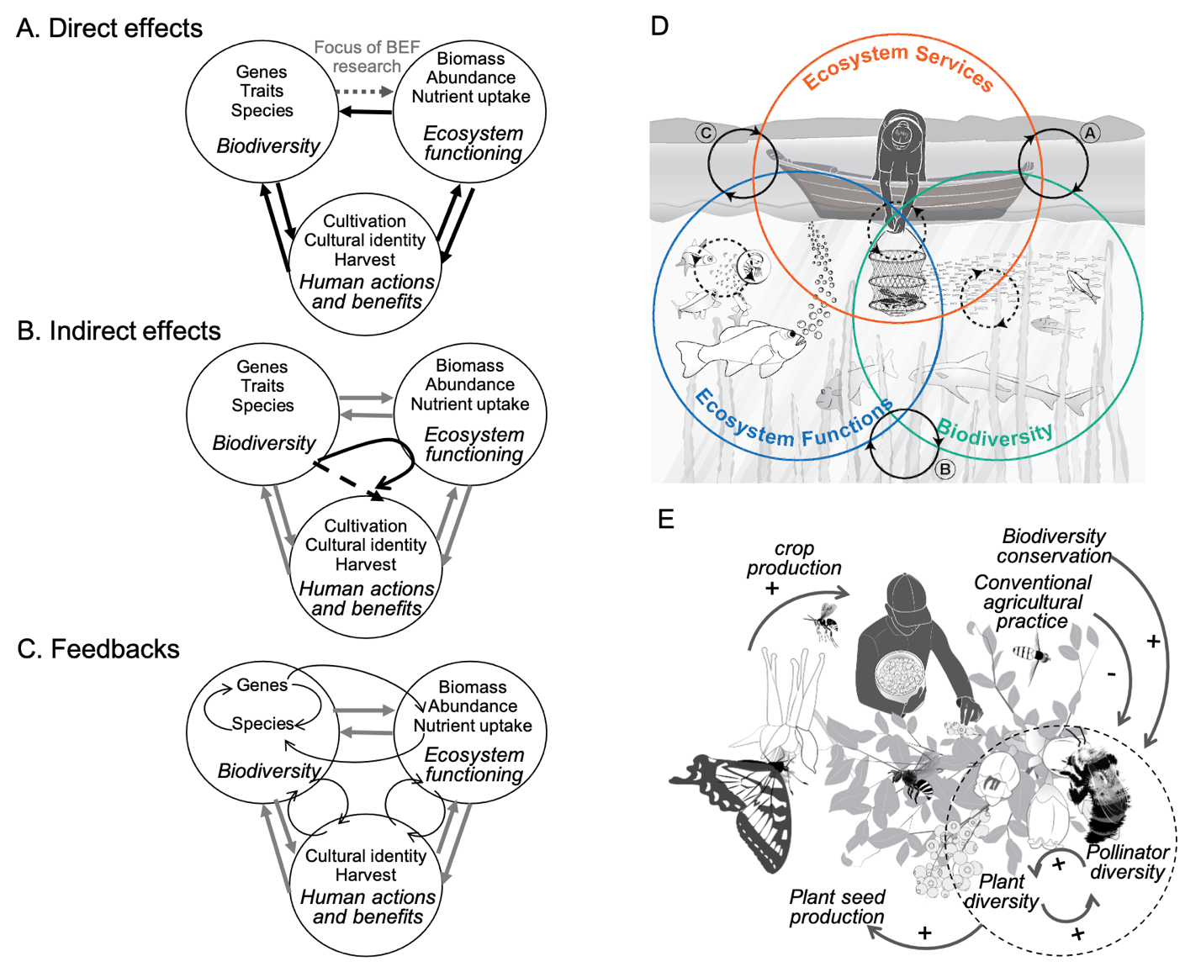

Figure 2. Feedbacks in population dynamics (A-B) and community dynamics (C): A) negative and B) positive feedback between population growth rate (dN/dt) and population density (N_{t}) in closed systems comprising one population. C) Density dependent feedbacks among plant populations and species can lead to a positive effect of plant diversity on plant productivity (an ecosystem function). Nutrient supply can modify the relationship between diversity and productivity by directly enhancing productivity and by changing plant diversity and composition. Whether there is a feedback between nutrient supply, diversity and productivity is not yet fully resolved (the red question mark).

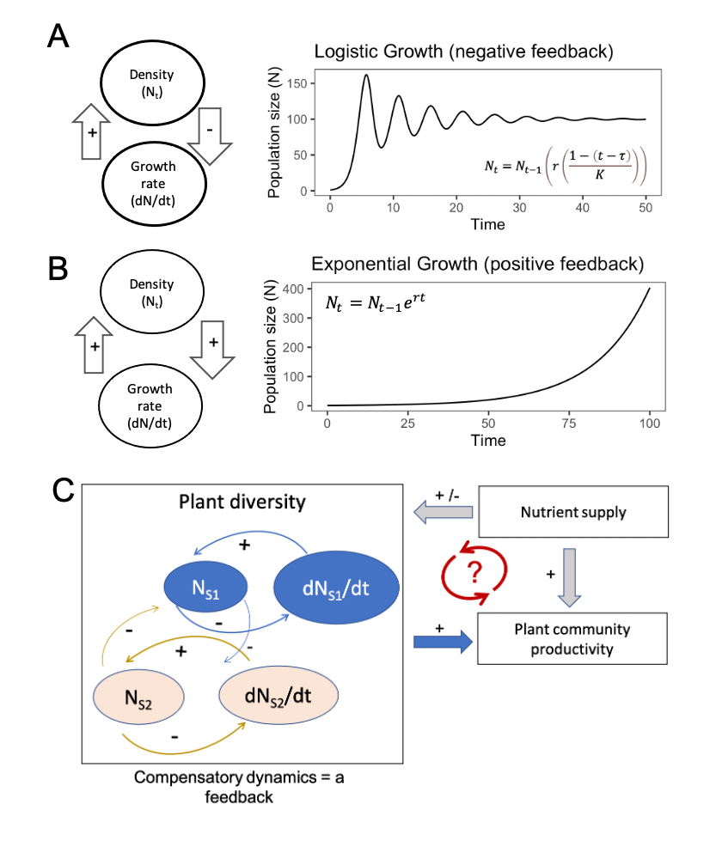
Figure 3. Models, experiments and observation systems are needed that explicitly address feedbacks and scales of space, time and biological organization. A) Current observation or experimental programs tend to focus in one part of this space – for example, generating data within the dashed box – and we argue that we need to develop approaches for understanding feedbacks that would relate observations at multiple scales within the focal system (the box) and at other scales (the upper right-hand cloud) (modified from Gonzalez et al 2020). B) When possible, the knowledge we generate via observations, theory, models and experiments must involve the biodiversity, ecosystem function and human components at each level. Hypothetical data are copied from panel A, illustrating that we should strive for observations and understanding of how biodiversity, human activities and ecosystem functions change at the same levels of spatial and temporal resolution, in the context of other spatial and temporal processes (panel A).

A)

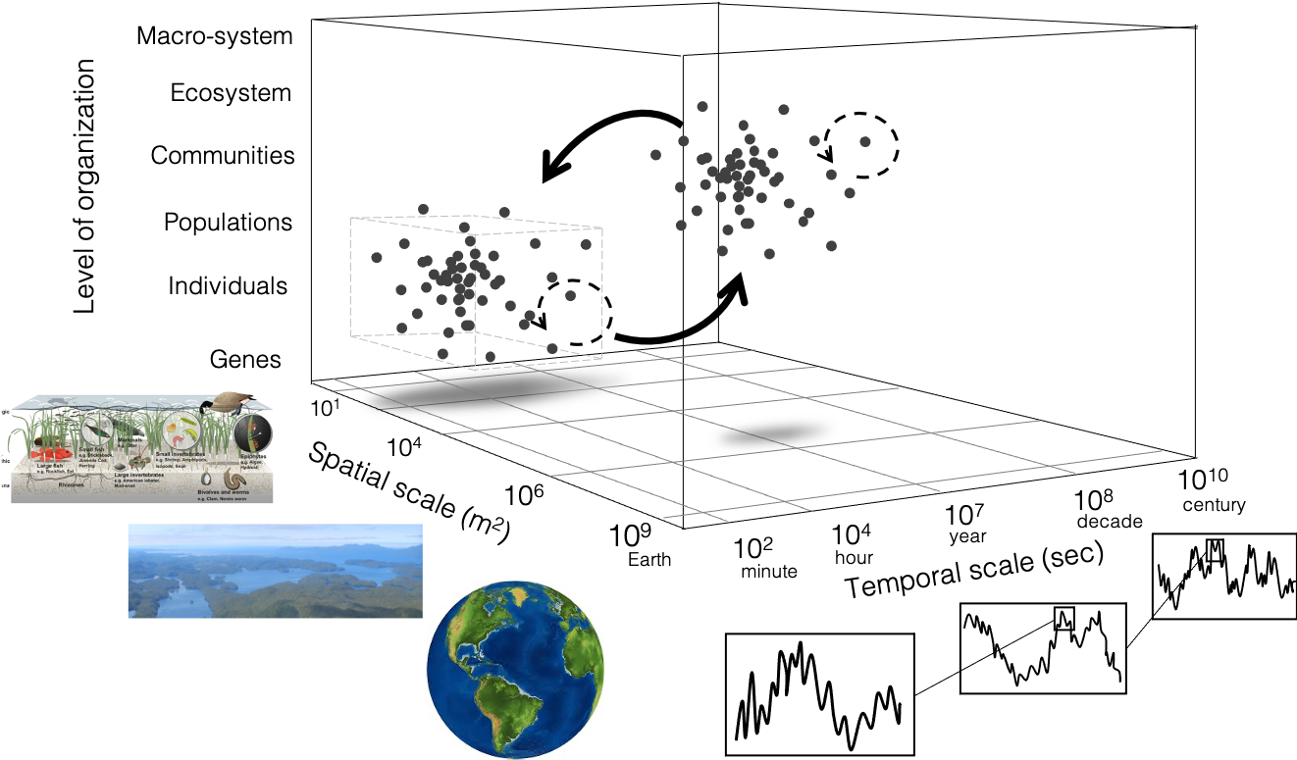

B)
