Box 3: Conceptualizations of the biodiversity - function system and its inclusion of humans have evolved over time in western science. The way biodiversity and ecosystem function feedbacks have been considered in the context of humanity’s relationship with nature has changed over the last half-century, and continues to change. Natural scientists and historians in many knowledge traditions have recognized the interdependencies of biodiversity and human well-being. In the early 1800s von Humboldt (1817) noted that deforestation would feedback to negatively impact society, and Darwin noted biodiversity and ecosystem functioning feedbacks (Hector and Hooper, 2002) long before our current awareness of them. Still, these feedbacks did not feature in the dominant western science paradigm of the 1950s to 1980s of conservation of nature for itself (Loreau, 2010; Naeem, 2002) (Figure A). Biodiversity-functioning relationships were raised in the 1980s, with the realization that extinctions of species might reduce ecosystem functioning Ehrlich and Mooney (1983), an example is Ehrlichs’ analogy of species loss as the popping of rivets in spaceship Earth; (Mace, 2014)). In the 1990s, biodiversity - ecosystem functioning - ecosystem services became a formal field of research spurred by seminal publications by Tilman and colleagues (1996), and Daly (1997). This progress was concurrent with a shift to a ‘nature for people’ in framing ecological policy.
In contemporary framings, the emphasis on biodiversity-function feedbacks is mixed, with some approaches that include a link between diversity and function (e.g., ecosystem stability) while others treat biodiversity as purely responsive to global change drivers (e.g., the resilience and planetary boundary frameworks, which do not explicitly relate biodiversity and ecosystem function). The most recent scientific developments converge with themes in many cultures that envision biodiversity as inclusive of people and human behavior (United Nations 2015, Diaz et al. 2019). The current IPBES framework (Figure 1B) that maps biodiversity, function and people begins to include feedbacks among these elements of the biosphere, with particular emphasis on socio-economic feedbacks (Figure 1B). The agenda we propose aims to frame the relationships among biodiversity – inclusive of people - and function to emphasize a strong scientific understanding of feedbacks across scales.

Figure X: We suggest that feedbacks between people, biodiversity, and ecosystem function be the next focus of conceptualizations of biodiversity-ecosystem function science.
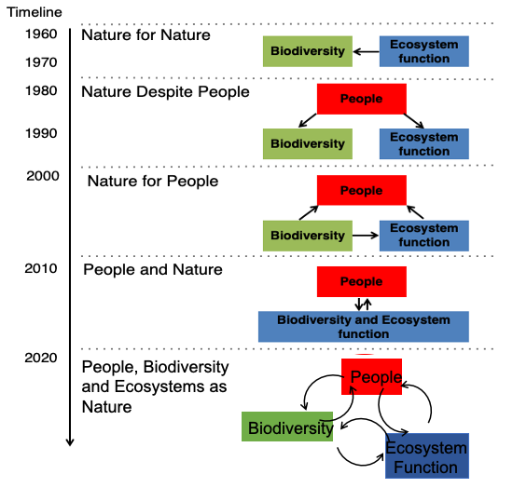

References:
Hector, A., Hooper, R., 2002. Darwin and the First Ecological Experiment. Science 295, 639.
Loreau, M., 2010. The Challenges of Biodiversity Science. International Ecology Institute, Oldendorf/Luhe, Germany.
Mace, G.M., 2014. Whose conservation? Science 345, 1558–1560. https://doi.org/10.1126/science.1254704
Naeem, S., 2002. Ecosystem consequences of biodiversity loss: the evolution of a paradigm. Ecology 83, 1537–1552.

