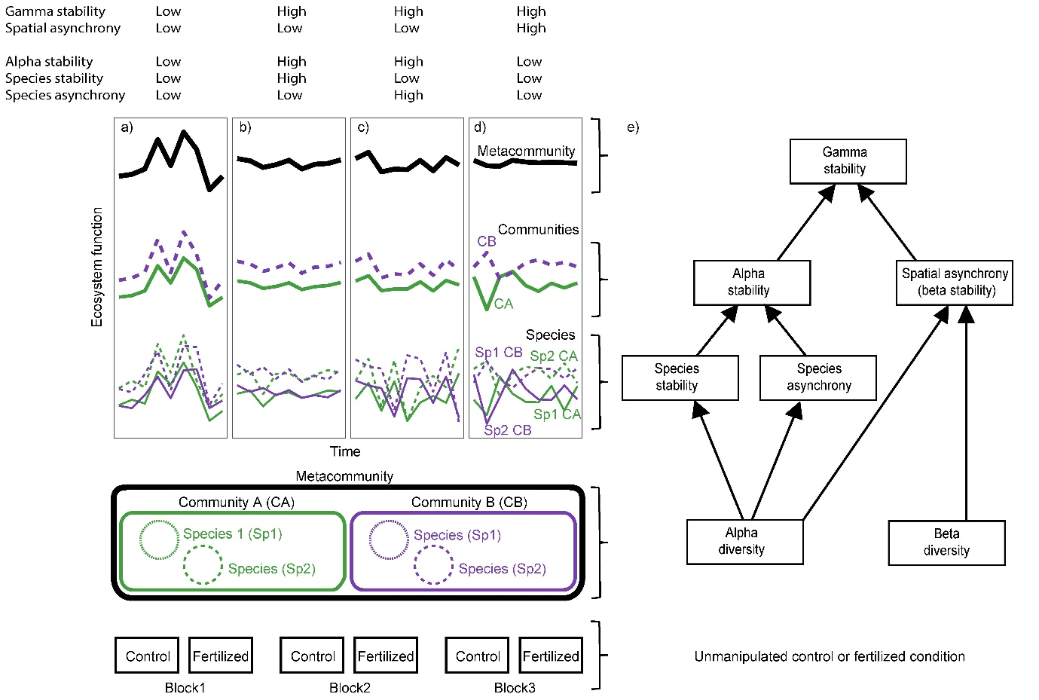
Figure 1. Conceptual figure illustrating the non-exclusive ways by which species stability, species asynchrony and spatial asynchrony may contribute to stabilize community (alpha stability) and meta-community (gamma stability) functioning (such as productivity) under unmanipulated control or fertilized condition. a) Low stability and asynchrony of species within communities result in low alpha stability that in turn results in low gamma stability under low degree of asynchronous dynamics among communities (spatial asynchrony or beta stability). Relatively high alpha and gamma stability may result from b) high species stability and c) high species asynchrony. d) Relatively high gamma stability may additionally result from high spatial asynchrony. e) Multivariate statistical model used to assess the contribution of alpha (species richness and evenness) and beta diversity to the mechanisms promoting stability at multiple spatial scales under unmanipulated control or fertilized condition.

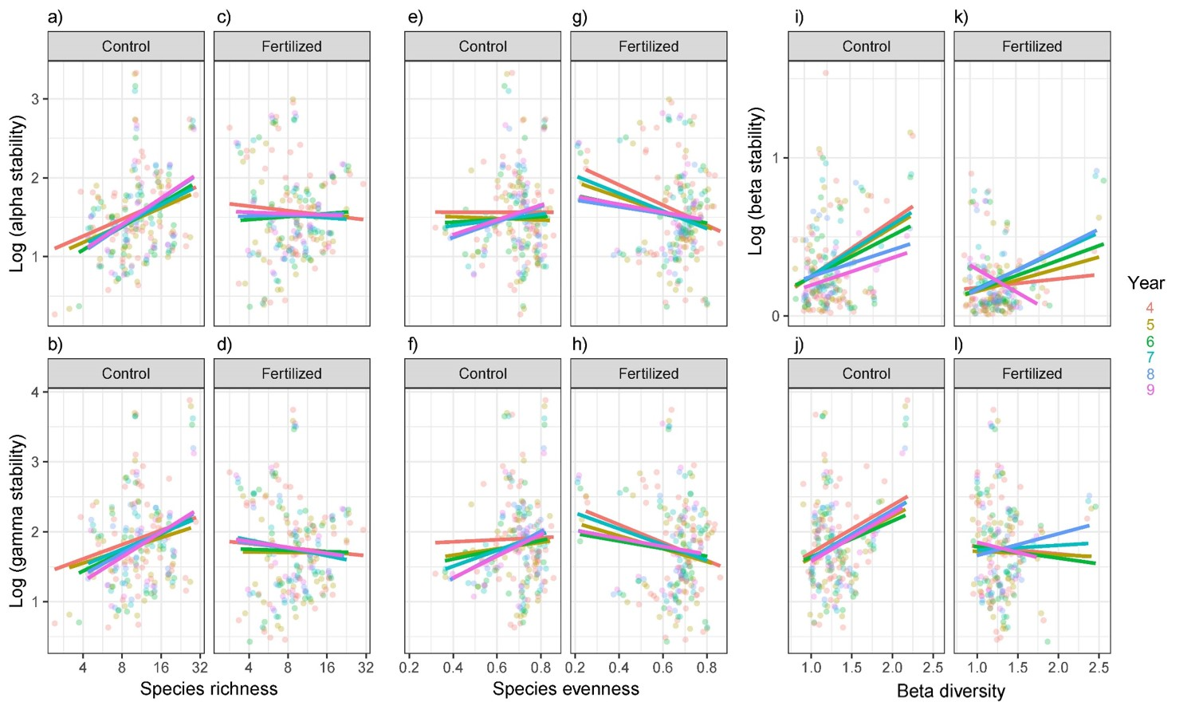
Figure 2. Impact of fertilization on biodiversity-stability relationships across spatial scales. Relationships were generally consistent among the periods of experimental duration considered (Table S3). Richness was positively associated with a) alpha (slope and 95% CIs across time = 0.26 (0.15 – 0.37)) and b) gamma stability (0.24 (0.11 – 0.37)) in the unmanipulated communities, but unrelated to both c) alpha (-0.014 (-0.12 – 0.10)) and d) gamma stability (-0.05 (-0.18 – 0.08)) in the fertilized communities. Evenness was unrelated with e) alpha stability 0.30 (-0.44 – 1.05)) and positively related with f) gamma stability (0.82 (0.06 – 1.70)) in the unmanipulated communities, but negatively associated with both g) alpha (-0.86 (-1.47 – -0.25)) and h) gamma stability (-0.88 (-1.59 – -0.16)) in the fertilized communities. Abundance-based beta diversity was positively related to i) beta (0.32 (0.20 – 0.44)) and j) gamma stability in the unmanipulated communities (0.48 (0.20 – 0.76)), but unrelated to k) beta (0.12 (-0.01 – 0.24)) and l) gamma stability in the fertilized communities (-0.05 (-0.35 – 0.25)).
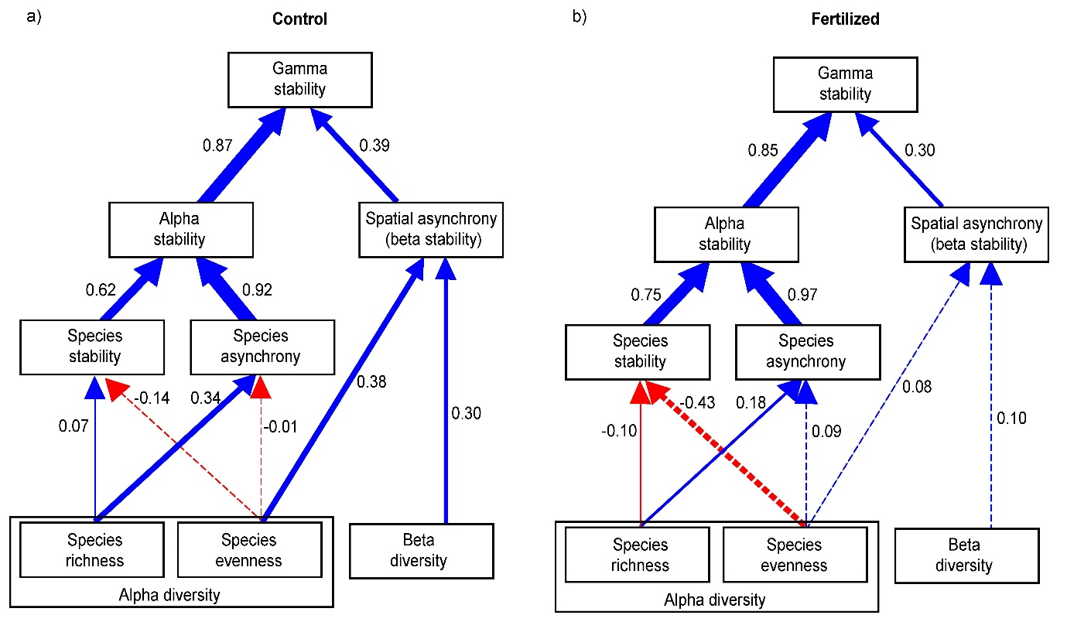
Figure 3. Summary of meta-analysis results showing the direct and indirect pathways through which biodiversity, asynchrony and stability at multiple spatial scales determines gamma stability under a) unmanipulated control or b) fertilized condition. Boxes represent measured variables and arrows represent relationships among variables. Numbers next to the arrows are averaged effect sizes as standardised path coefficients. Solid blue and red arrows represent significant (P ≤ 0.05) positive and negative coefficients, respectively, and dashed blue and red arrows represent non-significant coefficients. Widths of paths are scaled by standardized path coefficients.
Table 1. Summary of results from meta-analysis of model paths, including average effect sizes and 95% confidence intervals (CIs) for the paths in the statistical multivariate model (Fig. 1e).
 | Control |  | Fertilized
Pathway | Effect size | 95% CIs | Effect size | 95% CIs
Richness -> Species stability | 0.07 | -0.01 – 0.14 | -0.10 | -0.18 – -0.01
Evenness -> Species stability | -0.14 | -0.63 – 0.35 | -0.43 | -0.90 – 0.45
Richness -> Species asynchrony | 0.34 | 0.23 – 0.45 | 0.18 | 0.05 – 0.32
Evenness -> Species asynchrony | -0.01 | -0.73 – 0.73 | 0.09 | -0.63 – 0.82
Evenness -> Spatial asynchrony | 0.38 | 0.06 – 0.71 | 0.08 | -0.18 – 0.34
Beta -> Spatial asynchrony | 0.30 | 0.16 – 0.45 | 0.10 | -0.03 – 0.23

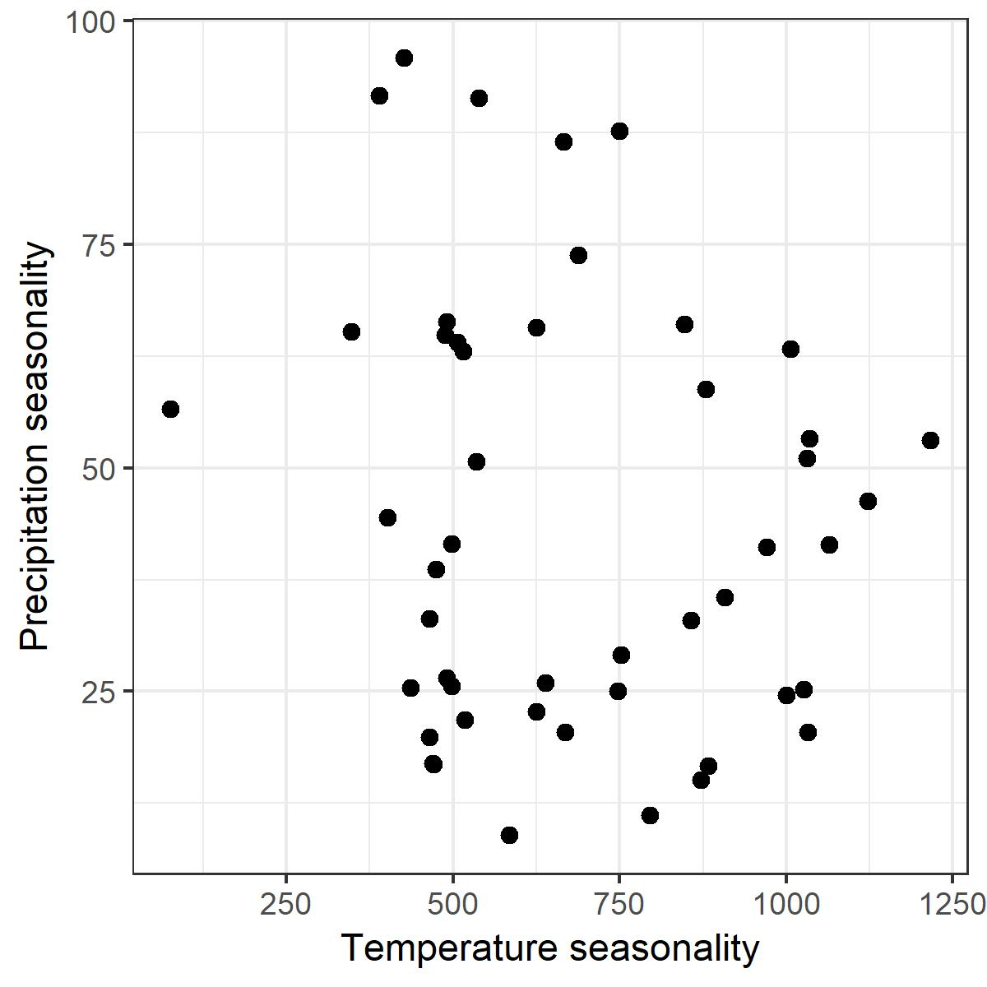
Figure S1. Study sites represent a wide range of temperature and precipitation seasonality (n=48).
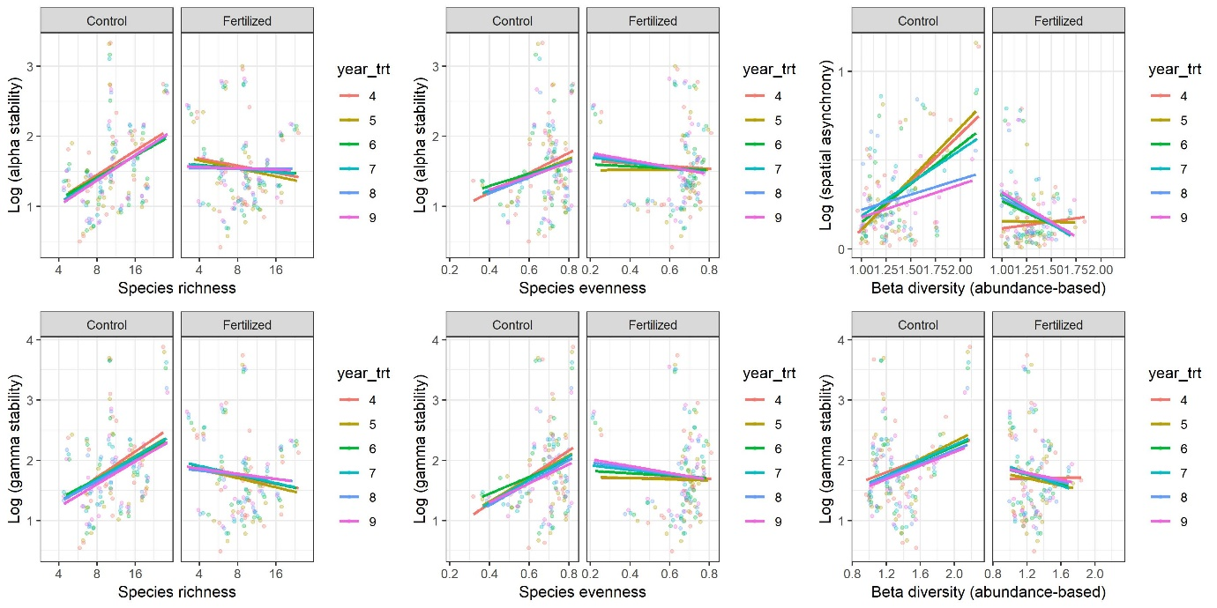
Figure S2. Impact of fertilization on biodiversity-stability relationships across spatial scales using 23 sites with nine years of duration.

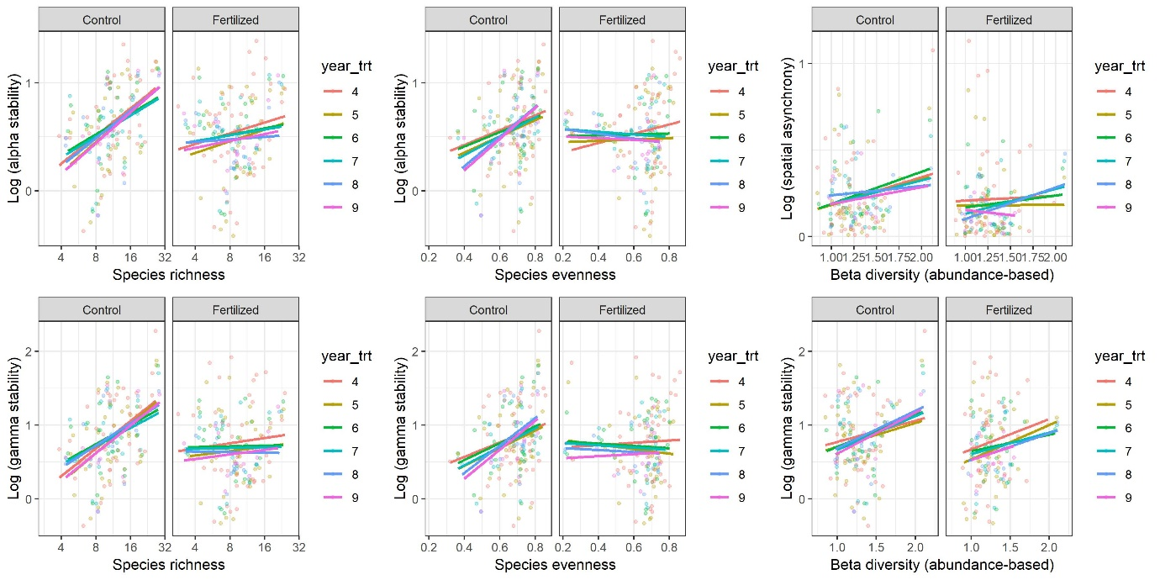
Figure S3. Impact of fertilization on biodiversity-stability relationships across spatial scales using biomass estimates instead of percentage cover.
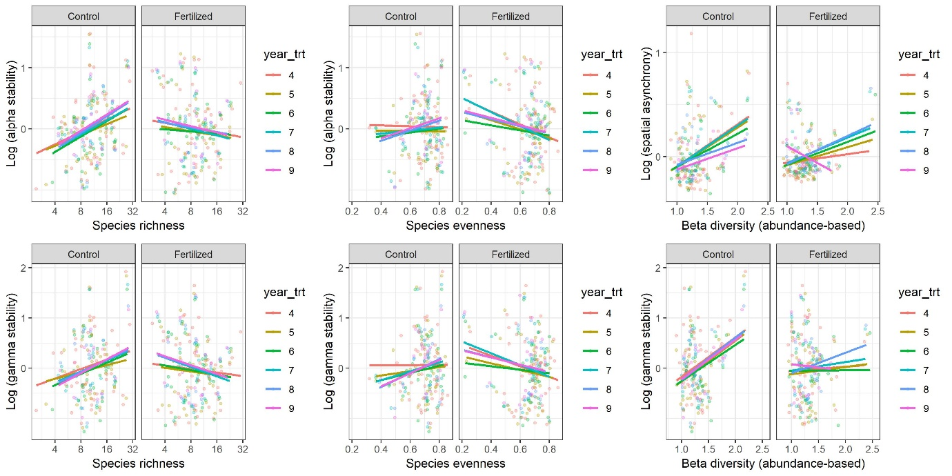
Figure S4. Impact of fertilization on biodiversity-stability relationships across spatial scales after controlling for inter-annual climate variability (analyses run of the residuals of models that included the coefficient of variation among years for each of temperature and precipitation).
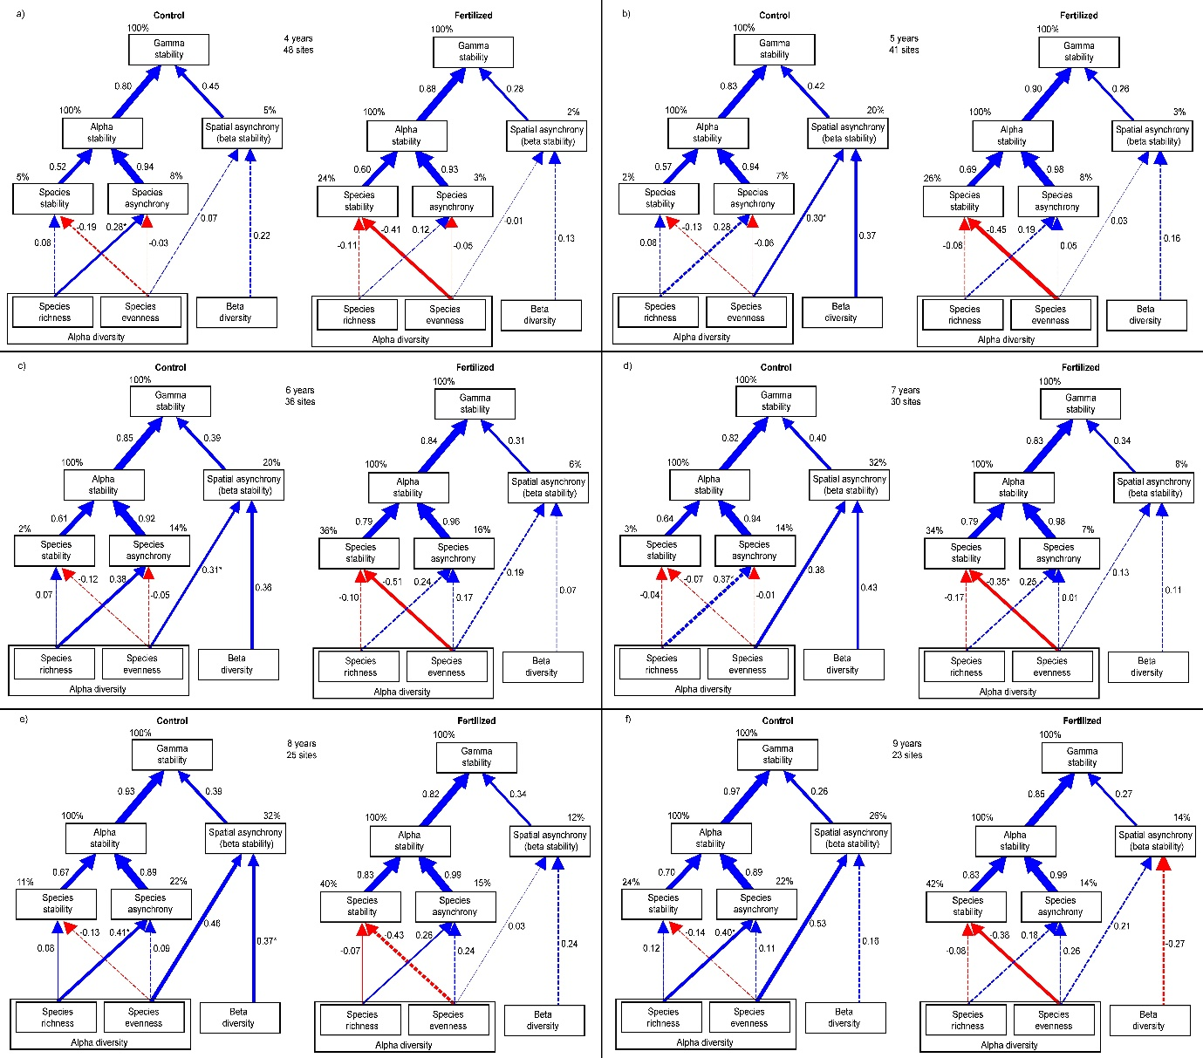
Figure S5. Structural equation modelling (SEM) showing the direct and indirect pathways through which biodiversity, asynchrony and stability at multiple spatial scales determines gamma stability. SEM model shown in Fig. 1e was evaluated separately for each period of experimental duration and treatment. Boxes represent measured variables and arrows represent relationships among variables. Numbers next to the arrows are averaged effect sizes as standardised path coefficients. Solid blue and red arrows represent significant (P ≤ 0.05) positive and negative coefficients, respectively, and dashed blue and red arrows represent non-significant coefficients. Widths of paths are scaled by standardized path coefficients. Percentages next to endogenous variables indicate the variance explained by the model (R²).

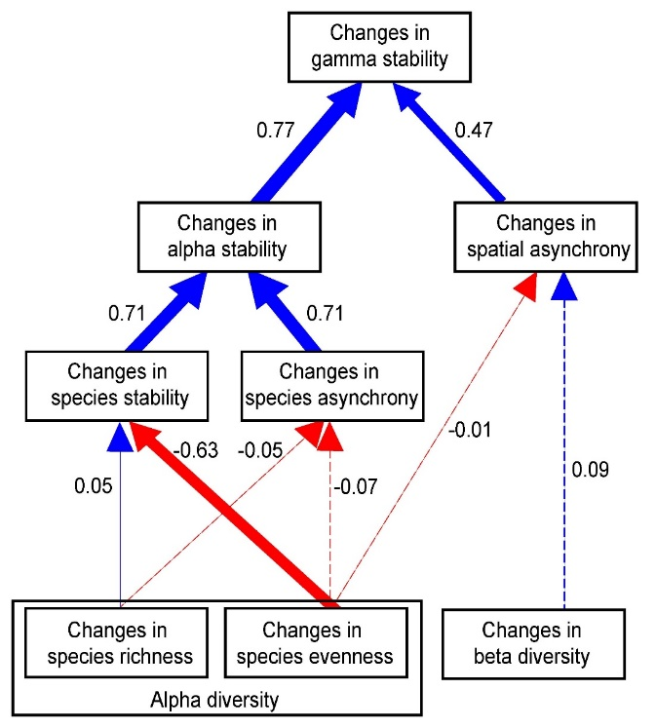
Figure S6. Summary of meta-analysis results showing the direct and indirect pathways through which changes in biodiversity, asynchrony and stability in response to fertilization at multiple spatial scales determines changes in gamma stability under a) unmanipulated control or b) fertilized condition. Boxes represent measured variables and arrows represent relationships among variables. Numbers next to the arrows are averaged effect sizes as standardised path coefficients. Solid blue and red arrows represent significant (P ≤ 0.05) positive and negative coefficients, respectively, and dashed blue and red arrows represent non-significant coefficients. Widths of paths are scaled by standardized path coefficients. Relative changes were calculated as the natural logarithm of the ratio of the variable within each fertilized meta-community divided by the average of the variable in the unmanipulated control meta-community at each site.
a) b)
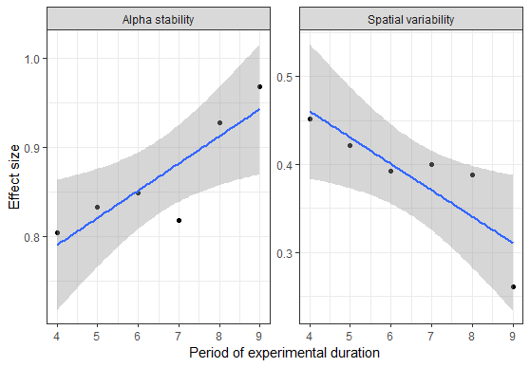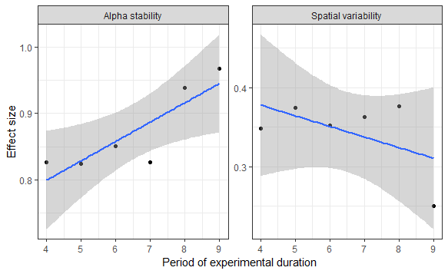
Figure S7. Standardized effect size of the contribution of alpha stability and spatial asynchrony to gamma stability in unmanipulated metacommunities through time in a) 48 sites with four years of experimental duration to 23 sites with nine years of duration and b) 23 sites each with nine years of experimental duration.

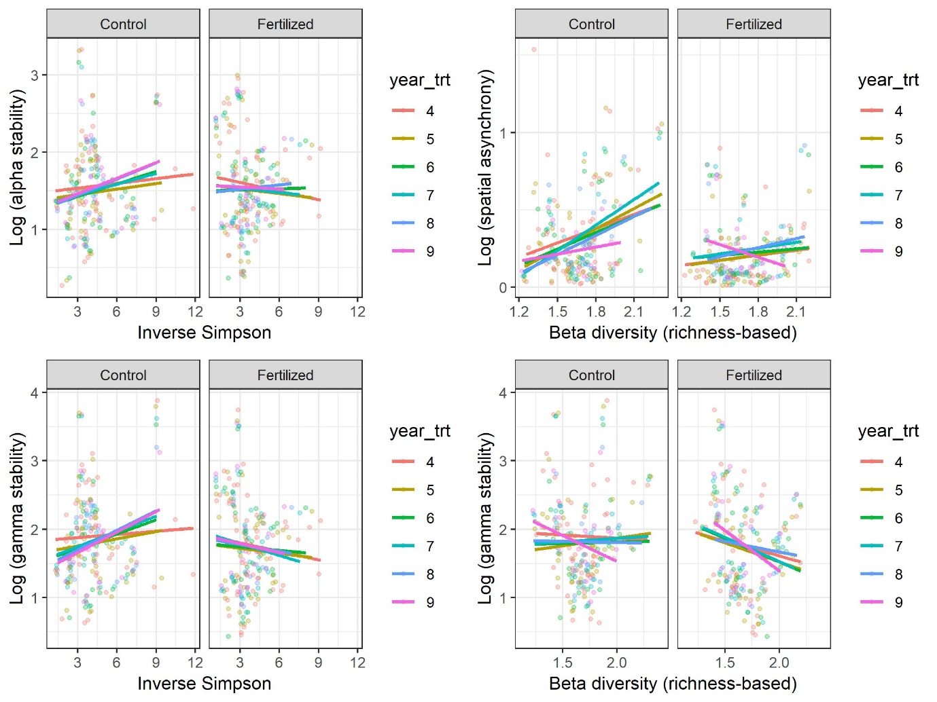Figure S8. Impact of fertilization on biodiversity-stability relationships across spatial scales for inverse Simpson and richness-based beta diversity indices.
Table S1. Hypotheses related to key predictions from theories relating biodiversity, asynchrony and stability at multiple spatial scales.
Pathway | Hypotheses and mechanisms | References
Community scale
Species richness -> species stability | Higher plant richness within a community either increases or decreases species stability within the community. | Tilman et al. 2006, Thibaut and Connolly 2013, Hector et al. 2010
Species evenness -> species stability | Higher evenness of species abundances within a community decreases the dominance of highly stable species. | Polley et al. 2007
Species richness -> species asynchrony | Higher plant richness within a community provides greater likelihood for asynchronous fluctuations among species to compensate one another when the number of species is higher. | Loreau and de Mazancourt 2008
Species evenness -> species asynchrony | Higher evenness of species abundances within a community provides greater likelihood for asynchronous fluctuations among species to compensate one another when species abundances are more equal. | Doak et al. 1998, Loreau 2010
Species stability -> alpha stability | Higher species stability within the community increases or decreases the stability of community productivity. | Wang et al. 2014, Hector et al. 2010
Species asynchrony -> alpha stability | Higher species asynchronous responses to environmental fluctuations within the community increases the stability of community productivity because declines in the abundance of some species are compensated for by increases in others, thus buffering temporal fluctuation in the abundance of the whole community (temporal insurance). | Yachi & Loreau 1999
Metacommunity scale
Species evenness -> spatial asynchrony | Higher evenness of species abundances provides greater opportunities for asynchronous fluctuations between communities to compensate one another because, when evenness is low, community dynamics across localities are driven by a few very abundant species that are more likely to respond similarly to environmental fluctuations, compared with when evenness is high. | No theoretical or empirical studies to our knowledge
Beta diversity -> spatial asynchrony | Higher variation and dissimilarity in species composition among communities increase asynchronous community responses to environmental fluctuations. | Wang and Loreau 2016
Spatial asynchrony -> gamma stability | Higher asynchronous community responses to environmental fluctuations increase metacommunity temporal stability because declines in the abundance of some communities are compensated for by increases in others, thus buffering temporal fluctuation in the abundance of the whole metacommunity (spatial insurance). | Loreau 2003 PNAS

Table S2. Sites contributing experimental data.
Site | Continent | Country | Type | Latitude | Longitude | Average richness | Temperature seasonality | Precipitation seasonality | Year of first nutrient addition | Omitted
azi.cn | Asia | CN | alpine grassland | 33.7 | 101.9 | 29.7 | 749.6 | 87.7 | 2008 | -
bogong.au | Australia | AU | alpine grassland | -36.9 | 147.3 | 18.1 | 490.0 | 26.5 | 2010 | -
burrawan.au | Australia | AU | semiarid grassland | -27.7 | 151.1 | 9.3 | 497.5 | 41.5 | 2009 | -
cbgb.us | America | US | tallgrass prairie | 41.8 | -93.4 | 8.4 | 1122.1 | 46.3 | 2010 | Blocks 4, 5, 6 *
cdcr.us | America | US | tallgrass prairie | 45.4 | -93.2 | 10.6 | 1215.7 | 53.1 | 2008 | Blocks 4, 5
cdpt.us | America | US | shortgrass prairie | 41.2 | -101.6 | 11.3 | 1006.8 | 63.3 | 2008 | Blocks 1, 5, 6 *
cereep.fr | Europe | FR | old field | 48.3 | 2.7 | 13.3 | 584.8 | 8.9 | 2013 | -
chilcas.ar | America | AR | mesic grassland | -36.3 | -58.3 | 10.7 | 497.6 | 25.6 | 2014 | -
comp.pt | Europe | PT | annual grassland | 38.8 | -8.8 | 21.4 | 515.7 | 63.0 | 2013 | -
cowi.ca | America | CA | old field | 48.8 | -123.6 | 4.8 | 487.9 | 64.9 | 2008 | -
elliot.us | America | US | annual grassland | 32.9 | -117.1 | 10.7 | 389.3 | 91.6 | 2009 | -
ethass.au | Australia | AU | desert grassland | -23.6 | 138.4 | 2.4 | 625.3 | 65.7 | 2014 | -
frue.ch | Europe | CH | pasture | 47.1 | 8.5 | 13.9 | 625.6 | 22.7 | 2009 | -
hall.us | America | US | tallgrass prairie | 36.9 | -86.7 | 6.3 | 871.4 | 15.1 | 2008 | -
hart.us | America | US | shrub steppe | 42.7 | -119.5 | 8.8 | 747.4 | 25.0 | 2008 | -
hero.uk | Europe | UK | mesic grassland | 51.4 | -0.6 | 16.0 | 469.1 | 17.0 | 2008 | -
hopl.us | America | US | annual grassland | 39.0 | -123.1 | 19.4 | 538.8 | 91.4 | 2008 | -
jena.de | Europe | DE | grassland | 50.9 | 11.5 | 18.4 | 667.9 | 20.4 | 2015 | -
kbs.us | America | US | old field | 42.4 | -85.4 | 12.5 | 1000.7 | 24.5 | 2014 | -
kibber.in | Asia | IN | alpine grassland | 32.3 | 78.0 | 5.3 | 1064.4 | 41.4 | 2012 | Blocks 4, 5
kilp.fi | Europe | FI | tundra grassland | 69.1 | 20.9 | 24.9 | 857.6 | 33.0 | 2014 | -
kiny.au | Australia | AU | semiarid grassland | -36.2 | 143.8 | 9.5 | 517.4 | 21.8 | 2008 | -
koffler.ca | America | CA | pasture | 44.0 | -79.5 | 8.1 | 1032.4 | 20.4 | 2011 | Plots 9, 11, 17, 21, 34, 36 *
konz.us | America | US | tallgrass prairie | 39.1 | -96.6 | 15.3 | 1031.3 | 51.0 | 2008 | -
lancaster.uk | Europe | UK | mesic grassland | 54.0 | -2.6 | 10.3 | 436.6 | 25.4 | 2009 | -
look.us | America | US | montane grassland | 44.2 | -122.1 | 6.9 | 490.4 | 66.3 | 2008 | -
marc.ar | America | AR | grassland | -37.7 | -57.4 | 11.4 | 464.9 | 19.9 | 2012 | Plots 6, 8, 11, 17 *
mtca.au | Australia | AU | savanna | -31.8 | 117.6 | 14.1 | 534.3 | 50.7 | 2009 | Block 4 *
ping.au | Australia | AU | old field | -32.5 | 117.0 | 7.0 | 506.6 | 64.0 | 2014 | -
pinj.au | Australia | AU | pasture | -27.5 | 152.9 | 3.8 | 401.5 | 44.5 | 2014 | -
rook.uk | Europe | UK | mesic grassland | 51.4 | -0.6 | 9.7 | 470.9 | 16.8 | 2008 | -
saana.fi | Europe | FI | montane grassland | 69.0 | 20.8 | 24.7 | 908.2 | 35.6 | 2015 | -
sage.us | America | US | montane grassland | 39.4 | -120.2 | 12.2 | 688.4 | 73.8 | 2008 | -
saline.us | America | US | mixedgrass prairie | 39.1 | -99.1 | 10.6 | 1034.8 | 53.3 | 2008 | -
sedg.us | America | US | annual grassland | 34.7 | -120.0 | 6.8 | 426.8 | 95.9 | 2008 | Plots 7, 10, 17, 18, 27, 28
sereng.tz | Africa | TZ | savanna | -2.3 | 34.5 | 12.3 | 76.2 | 56.6 | 2009
sevi.us | America | US | desert grassland | 34.4 | -106.7 | 6.3 | 846.8 | 66.1 | 2008 | Plots laid out in completely randomized design. Assigned to five pseudo-blocks, as spatially contiguous as possible, and omitted those from pseudo-blocks 2 and 4. *
sgs.us | America | US | shortgrass prairie | 40.8 | -104.8 | 7.2 | 879.7 | 58.8 | 2008
shps.us | America | US | shrub steppe | 44.2 | -112.2 | 15.8 | 970.2 | 41.1 | 2008 | Block 4
sier.us | America | US | annual grassland | 39.2 | -121.3 | 8.1 | 665.2 | 86.5 | 2008 | Blocks 4, 5
smith.us | America | US | mesic grassland | 48.2 | -122.6 | 19.3 | 474.8 | 38.7 | 2008 | -
spin.us | America | US | pasture | 38.1 | -84.5 | 10.2 | 882.4 | 16.6 | 2008 | -
temple.us | America | US | tallgrass prairie | 31.0 | -97.3 | 10.6 | 751.6 | 29.1 | 2008 | Plots 19, 20 *
trel.us | America | US | tallgrass prairie | 40.1 | -88.8 | 4.8 | 1026.6 | 25.2 | 2009 | -
ukul.za | Africa | ZA | mesic grassland | -29.7 | 30.4 | 15.8 | 347.3 | 65.3 | 2010 | Plots 8, 10, 19, 20, 25, 30
unc.us | America | US | old field | 36.0 | -79.0 | 11.6 | 795.6 | 11.2 | 2008 | -
valm.ch | Europe | CH | alpine grassland | 46.6 | 10.4 | 26.6 | 639.2 | 25.9 | 2009 | -
yarra.au | Australia | AU | mesic grassland | -33.6 | 150.7 | 5.3 | 465.0 | 33.2 | 2015 | Block 4

Table S3.
Species richness-> alpha stability
Denom. Df: | 382
 | Df | F-value | P-value
(Intercept) | 1 | 430.986 | <.0001
richness | 1 | 1.3359 | 0.2485
time | 5 | 0.6172 | 0.6868
treatment | 1 | 0.0156 | 0.9008
richness:time | 5 | 1.0757 | 0.3733
richness:treatment | 1 | 27.657 | <.0001
time:treatment | 5 | 0.0423 | 0.999
richness:time:treatment | 5 | 0.5626 | 0.7287
Species richness -> gamma stability
Denom. Df: | 382
 | Df | F-value | P-value
(Intercept) | 1 | 480.9393 | <.0001
richness | 1 | 0.9762 | 0.3238
time | 5 | 0.3752 | 0.8657
treatment | 1 | 5.805 | 0.0165
richness:time | 5 | 0.3173 | 0.9025
richness:treatment | 1 | 23.6893 | <.0001
time:treatment | 5 | 0.191 | 0.9659
richness:time:treatment | 5 | 0.885 | 0.4911
Species evenness -> alpha stability
Denom. Df: | 382
 | Df | F-value | P-value
(Intercept) | 1 | 400.4906 | <.0001
richness | 1 | 29.8971 | <.0001
time | 5 | 0.9342 | 0.4587
treatment | 1 | 1.459 | 0.2278
richness:time | 5 | 0.6751 | 0.6426
richness:treatment | 1 | 16.4267 | 0.0001
time:treatment | 5 | 0.0746 | 0.996
richness:time:treatment | 5 | 1.0267 | 0.4015
Species evenness -> gamma stability
Denom. Df: | 382
 | Df | F-value | P-value
(Intercept) | 1 | 476.4312 | <.0001
richness | 1 | 11.6344 | 0.0007
time | 5 | 0.4565 | 0.8085
treatment | 1 | 8.3672 | 0.004
richness:time | 5 | 0.7254 | 0.6047
richness:treatment | 1 | 19.8323 | <.0001
time:treatment | 5 | 0.2464 | 0.9415
richness:time:treatment | 5 | 1.5311 | 0.1791
Beta diversity -> alpha stability
Denom. Df: | 382
 | Df | F-value | P-value
(Intercept) | 1 | 182.9647 | <.0001
richness | 1 | 21.60575 | <.0001
time | 5 | 0.45484 | 0.8097
treatment | 1 | 21.06823 | <.0001
richness:time | 5 | 1.70575 | 0.1323
richness:treatment | 1 | 7.70224 | 0.0058
time:treatment | 5 | 1.19534 | 0.3108
richness:time:treatment | 5 | 0.30486 | 0.9099
Beta diversity -> gamma stability
Denom. Df: | 382
 | Df | F-value | P-value
(Intercept) | 1 | 553.792 | <.0001
richness | 1 | 3.966 | 0.0471
time | 5 | 0.3758 | 0.8652
treatment | 1 | 2.8192 | 0.094
richness:time | 5 | 0.4706 | 0.7981
richness:treatment | 1 | 8.7603 | 0.0033
time:treatment | 5 | 0.2986 | 0.9135
richness:time:treatment | 5 | 0.5877 | 0.7094

