Agenda 2070: Challenges for biodiversity-ecosystem functioning research for the next 50 years

STATUS: READY FOR REVIEW IF YOU WOULD LIKE TO WORK ON TEXT.
PLEASE TRACK CHANGES AND/OR WORK ON THE ‘WORKING TEXT’ DOC, HERE THEN PASTE IN HERE YOUR REVISED TEXT. LET’S WORK THIS WAY UNTIL MARCH 4].

Possible venues:
Current Opinions in The Environment and Sustainability (these are really short <2000 words, and invited; there is a longer version (<3000 words) and we can inquire). I’d like to know if, after reading this, you think we should aim for super-concise and the shorter version, or explain in more detail and aim for something longer - Bioscience perhaps?]

Does anyone have access to this Mace opinion? UBC doesn’t subscribe to Nature Sustainability: https://www-nature-com.ezproxy.library.ubc.ca/articles/s41893-018-0130-0

Abstract [100-200 words]:

International science and policy efforts to protect biodiversity require the best possible scientific understanding of biodiversity trends, ecosystem functions, and - critically - the feedbacks between them across spatial scales. However, we currently lack the scientific knowledge, in the form of data or models, on biodiversity change and its feedbacks with ecosystem functioning and services to implement existing framework with confidence, now and into the future. Here, we outline a research agenda to meet this challenge, to better support global efforts to maintain a sustainable biosphere. We identify 9 knowledge gaps in the realm of biodiversity and ecosystem functioning science. We then consider current limitations to filing these gaps, and outline an agenda for action to achieve scientific progress for policy-relevant understanding.

I. Global science and policy efforts require scientific understanding of biodiversity and ecosystem functioning feedbacks across scale

Irreversible biodiversity change is considered one of the greatest ecological crises of our time [REF]. It is the primary motivation of international agreements and targets aimed at slowing global extinction rates and preventing the degradation of ecosystems to ensure a sustainable future for humanity (IPBES, etc). These three goals are inextricably linked. Human activities, from gardening to burning fossil fuels, alter the feedbacks that link biodiversity to ecosystem function. Biodiversity plays a key role in ecosystem functions, and changes to ecosystem functions such as productivity or resource cycling can feedback to alter biodiversity. These feedbacks reflect the exchanges of information and energy flow that underlie the sustainability of our biosphere, but including them in strategies to guide science-based policies across scales remains a challenge.

As humanity’s dominance of the planetary ecology accelerates, we have affirmed commitments to sustainable coexistence of humans and biodiversity from local to international levels (reference IPBES, resilience, Aichi CBD targets, SDGs, geobon, future earth?). The current flagship platform, IPBES, has committed to science-based assessments of the state of the human-nature relationship in an effort to guide policies and improve management (Figure 1b). This framework is based on the conceptual model of interactions between people and nature (biodiversity and ecosystem functions), and the belief that a sustainable future requires that we use scientific knowledge and tools to observe and model these interactions to guide policies.

Currently, we have science-based support for a general understanding of how humans affect biodiversity (Dirzo et al, Butchart et al, Newbold et al 2014, Ceballos et al 2015, Ripple et al 2019 conservation biology), how humans affect ecosystem function (IPCC, other good refs), how biodiversity affects ecosystem functioning (Cardinale et al, Reich et al) and how ecosystem functions affect humans (e.g., nature’s contributions to people)(Balvanera et al 2014,...) (Fig 2). These effects are most often understood as one-way relationships - one aspect of nature affects another. These one-way effects are essential, but incomplete, elements of complex biodiversity systems, and without understanding how they feedback on each other, knowledge of each effect does not provide sufficient information about how biodiversity and ecosystem function change occur across the scales that are relevant to many policy programs like those reviewed in Box 1 [Section II: 2]. We refer to the ‘stabilizing’ effects of biodiversity, or to the way biodiversity regulates ecosystem services (Mace et al 2012); yet stability and regulation require feedbacks and these feedbacks have been underutilized and under-emphasized in major science-policy frameworks (Box 1; make sure we’re clear on how they’ve been underutilized). Understanding the feedbacks between biodiversity, ecosystem function and human activities is essential to understanding how changes in any one of those elements affects others across scales. This is a critical knowledge gap that impedes our ability to robustly scale knowledge from observations to projections of broad scale or future states of biodiversity-function systems (Peters et al 2004).

International science and policy efforts to achieve a future with sustainable biodiversity, ecosystem function and human activities require the best possible scientific understanding of biodiversity, ecosystem functions, and - critically - the feedbacks between them and humanity across spatial scales. However, we currently lack the scientific knowledge, in the form of data or models, on changes to feedbacks between biodiversity, ecosystem functions and human activities to implement the framework with confidence. Here, we outline a research agenda to meet this challenge, to better support global efforts to maintain a sustainable biosphere. We begin by highlighting knowledge gaps in our current scientific understanding of biodiversity-ecosystem functioning feedbacks in a world in which humans are an integral part of the dynamic system [Box 1]. Then we outline X major scientific challenges that deserve organized and collaborative investment for rapid progress. Finally, we outline an agenda for action to meet these challenges to support policy-relevant science in a changing world, as our understanding of that world also changes.

--- Box 1--- Conceptualizations of the human - biodiversity - function system have evolved over time ---------

Although the link between biodiversity and ecosystem functioning is foundational, traced back to Darwin (Hector and Hooper 2002, Science), it went largely unrecognized for the first century of Ecology. From the 1950-80s the dominant framing was the conservation of nature for itself (Figure 1A), with an increasing realization that extinctions of species might have consequences for ecosystem functioning (the Ehrlichs’ analogy of species loss as the popping of rivets in spaceship Earth; Mace 2014). This led to the formation of a formal field of research on the relationship between biodiversity and ecosystem functioning that quickly established the existence of this link and the ‘services’ that humans derive from the natural world. This ‘nature for people’ framing rapidly led to the integration of ecology and environmental economics some of which acknowledge the link between diversity and function (payments for ecosystem services) and others that do not (natural capital [check this is not doing an injustice!]). Similarly, while some developments in natural sciences continue to include a link between diversity and function (e.g. ecosystem stability) other framings see biodiversity as purely responsive to global change drivers (the resilience and planetary boundary frameworks). The most recent developments are increasing incorporation of people and human behaviour (sustainable development goals, IPBES) and the juxtaposition of engineered (‘grey’) versus nature-based (‘green’) solutions to environmental problems (e.g., Keeler et al 2019).

IPBES is the current flagship framework for relating biodiversity, ecosystem functions and people to guide science-based policy.

Figure 1A: Development of additional Framings for the conservation of biodiversity over time (developed from Mace et al.) showing those that include the link between diversity and function (COLOUR arrows) versus the introduction and emphasis of other relationships (COLOUR arrows). Later framings complement (not replace) earlier ones, although some do not include the link between diversity and function. People and human activities were absent from earlier framings and have increasing prominence in more recent ones. Figure 1B: IPBES framework (reference).

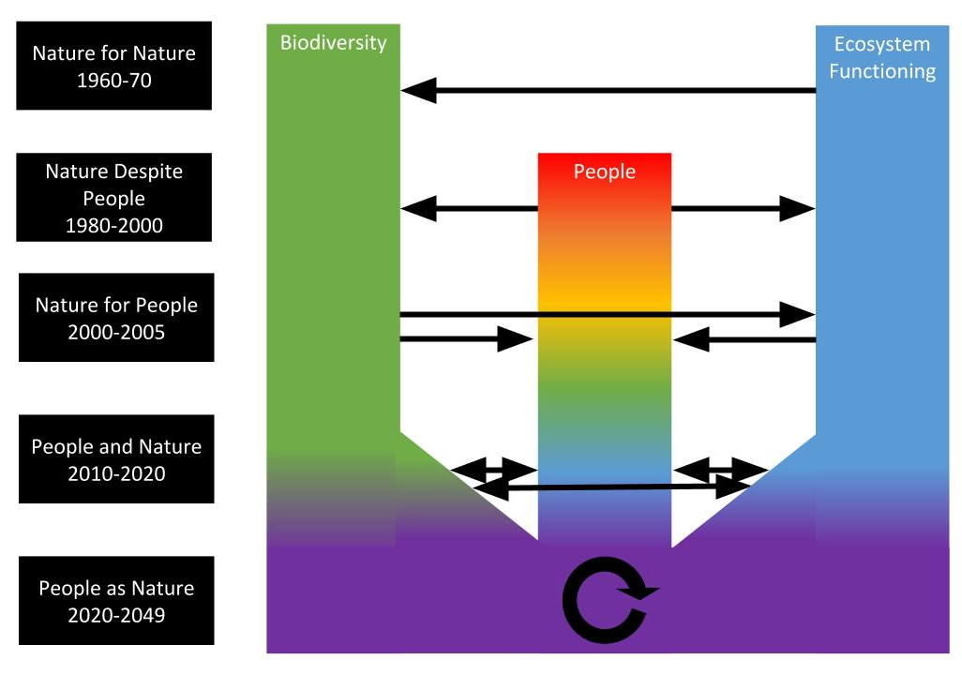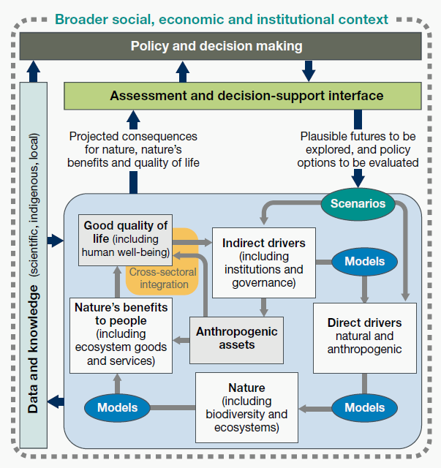

---- end Box 1----

II. People, biodiversity, ecosystem function feedbacks (PBEFF)
The biosphere is a system of feedbacks involving humans (a component of global biodiversity), non-human biodiversity and the functions (energy and material exchanges) occurring in ecosystems (the joint abiotic / biotic systems) on our planet. We know that many dimensions of biodiversity (Figure 2b) confer resilience and stability on biodiversity, humanity and ecosystem functions; yet a full understanding of when and how this occurs across scales is still lacking. Feedbacks inherently introduce nonlinear relationships between elements and states of systems (Peters et al 2004), such that observations of biodiversity without related observations of function at one time may not predict future states. Without considering feedbacks in these elements of living systems, efforts to project future states may be limited, even with large amounts of observations in hand (Peters et al 2004).
While biodiversity, ecosystem functions and human systems each changes and affects the other, additionally, feedbacks between these elements of complex living systems create ecological and social dynamics across scales. Feedbacks are more than a set of one-way interactions; feedbacks are dynamical structures of complex systems that can determine the stability and future trajectories of these systems. In negative feedbacks, interacting elements of a system are self-damping and stabilizing. In contrast, in positive feedbacks, changes within a system are self-reinforcing and potentially destabilizing. For example, productive grasslands can shift to deserts in a process called ‘desertification’ when positive feedbacks between plant diversity and function (productivity, biomass, moisture retention in the system) are disrupted by diversity loss or climate change, and soils dry. As the ecosystem desertifies, form functions of plant production and moisture retention are lost, and biodiversity cannot recover, in a negative feedback between soil drying and plant diversity. The ultimate consequence is a shift in ecosystem state to a less desirable state to humans (D’Odorico et al 2013) - a landscape scale change mediated by the balance of feedbacks between plants and their environment at finer spatial scales.
[Negative feedbacks can buffer systems against change, which might help achieve conservation goals in some contexts, but might also make it difficult to alter systems through active management. For example, due to negative feedbacks between productivity and biodiversity, short-term increases in biomass can ultimately lead to declines in local richness, which consequently reduces biomass (Isbell et al. 2013, PNAS). In contrast, positive feedbacks could help reinforce biodiversity effects over time - e.g. soil feedbacks and organic matter accumulation (Fornara et al. 2011, Ecol. Rec.), but they can also lead to runaway interactions that destabilize systems (Crespi 2004, TREE). Both types of feedback can be local, or they can involve interactions that play out across multiple spatial and temporal scales (Peters et al. 2004, PNAS).
Also mention in here: evolution is a feedback between diversity generating processes and the environment in which diversity exists
point to the feedbacks at community and populations scales that make us feel that remotely sensed trait or species data (layered SDMs) cannot fully capture BEF.]
Feedbacks between the changes in the human and non-human elements of biodiversity are ultimately driven by the fast recent and current growth of the global human population and economic activities. In turn, they affect human population dynamics and economic activities in the long run through changes in ecosystem functioning, and thereby in the provision of ecosystem services and human wellbeing. Thus, there are long-term feedbacks between human societies, biodiversity, and ecosystems, and these feedbacks are bound to become stronger and stronger as human populations and environmental impacts increase.
Linking observations and models across scales is central to capitalizing on the knowledge gained from mechanistic studies of the relationships between biodiversity and ecosystem function, yet without understanding feedbacks, these cross-scale linkages or efforts to scale up are incomplete, and remain a major current barrier to producing policy-relevant science.

Figure 2a: Simple depiction of PBEFF loops between biodiversity, people and ecosystem functions. Many feedback loops exist within and across biodiversity, function and people. Here, humans, as living organisms, are shown as a subset of biodiversity, and people are engaged in feedbacks with biodiversity itself, as well as function. (And I suppose also the BEF framework).
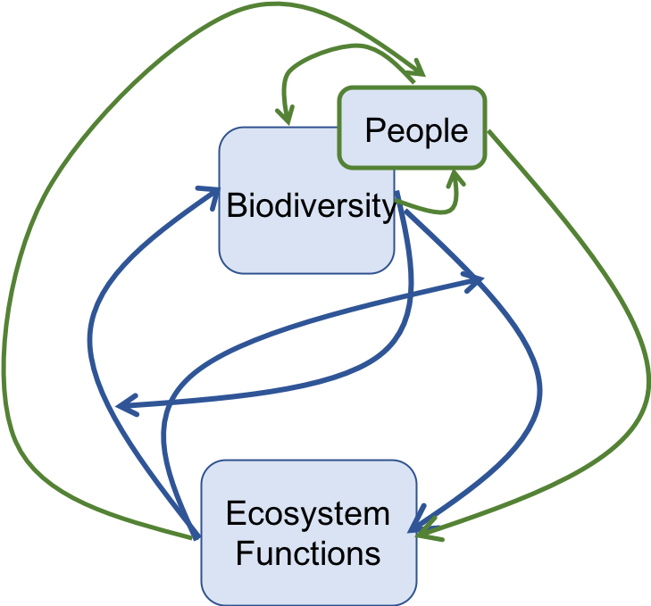
Figure 2b. Biodiversity across dimensions of life affect the abiotic environment and ecosystem function via the metabolism, behavior and activities of individual organisms, associated with the traits they express. Feedbacks exist between the abiotic environment, ecosystem functions, people, ecosystem services and biodiversity. We observe biodiversity and functions, and we value services, but we are still learning about how to observe and monitor the feedbacks that determine the ultimate stability and change of the entire system.
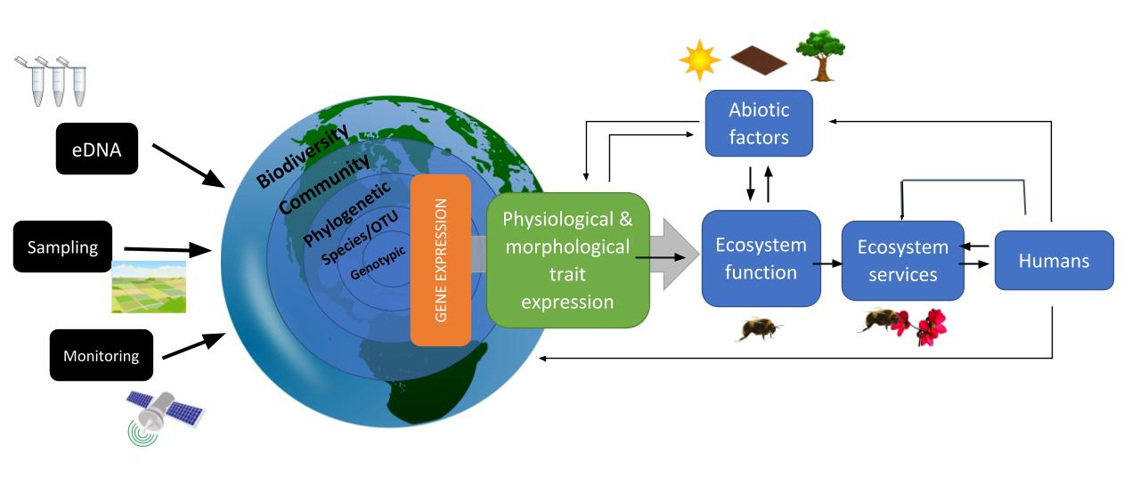
----

III. Grand challenges for Biodiversity Science. Scientific progress over the last 30 years has led to recognition of the importance of feedbacks among biodiversity, function and people across scales. Despite this understanding, and major progress with models, experiments and observations, major challenges remain to integrate this knowledge with new capabilities to meet the challenges of the coming decades. We know with high certainty that the elements involved on these feedbacks in the biosphere - human activities, ecosystem function and biodiversity will all change, as climate change and human population growth accelerates, and land use change continues. Without also accelerating our scientific understanding of these feedbacks and how they change, we will not be able to assess our capacity to manage a sustainable biosphere. Here, we outline 9 scientific challenges that we consider top priorities for major investment to enhance our knowledge frameworks to support the policies we are considering.

- What are the feedbacks between human societies, biodiversity and ecosystem function? [Michel] A major future challenge will be to account for the indirect effects of biodiversity on human societies and for the resulting feedbacks these effects have on biodiversity and ecosystems. A research agenda should aim toward an ultimate goal of fully including the multiple human (behavioral, demographic, social, political, economic, institutional) components of these feedbacks. There is growing recognition of the importance of the feedbacks that couple natural and social systems; some authors now even argue that the dynamics of either natural or human systems cannot be understood without considering these feedbacks explicitly. This is especially true at the global scale, where long-term feedbacks play a prominent role, but there is evidence that these feedbacks can be critical for projections of regional or local development or sustainability. Accounting for these feedbacks will be a particularly critical challenge for predictive models of BEF, especially those that aim to predict changes in biodiversity and ecosystems at large spatial scales.

- What are the major feedbacks between diversity and ecosystem function across scales? [MO, JC, JEB, Adam, Akira] Despite nearly three decades of experimental and theoretical development in the area of biodiversity and ecosystem functioning relationships, much of this work aimed to minimize feedbacks. In experiments, diversity is maintained at fixed levels in order to prevent feedbacks from confounding estimates of diversity effects. Consequently, we need to build on this strong basis for understanding how biodiversity affects ecosystem functions to better understand feedbacks to articulate long-term predictions about how diversity loss will influence natural systems.
We suggest that in order to move the field forward, researchers need to 1) observe the temporal dynamics of experiments with set initial conditions but without subsequent intervention; 2) utilize observational data and appropriate statistical techniques (e.g., panel data approaches) to identify naturally occurring feedbacks; and 3) devise research that utilizes multiscale manipulations and observations over time to disentangle when and where cross-scale feedbacks are important. Further, small scale biodiversity experiments largely fail to address long-term evolutionary processes. The majority of these processes may play out over millennia, but there is evidence to suggest that rapid environmental change paired with increased movement of species can lead to rapid speciation events via hybridization (cite Loren Rieseberg stuff).

3. How do different dimensions of biodiversity feedback with function? [was #2; Kim, Mary, Charlie] Biodiversity is hierarchical in nature (Figure 2b). Observations span dimensions of biodiversity, from genetic and phenotypic diversity to species diversity to phylogenetic diversity. Metabarcoding and eDNA methods are now accessible to individual researchers, and mega-databases include billions of observations of elements of diversity [how many genes catalogued, how many barcodes?]. The challenge is that we still do not have the scientific knowledge to relate changes in observed diversity in the environment from these observational approaches to estimates of changes in ecosystem function.
What we know: We know, by definition, that trait expression of an entire community is one driver of ecosystem function. For a given dimension of biodiversity (genetic, traits, species, phylogenetic) at a spatial and temporal scale within a few orders of magnitude of their body size and generation time, increased diversity is on average associated with increased ecosystem functions (Tilman et al PNAS 1997, Chesson et al book chapter in Tilman book), which has been extensively tested in hundreds of experiments (Cardinale et al 2011, O’Connor et al 2017). We also know that this functional expression can feedback to influence community dynamics based on historical experiments (Grime, Fridley, etc, but see Adler et al), as well as long-standing coexistence theory (Tilman et al PNAS 1997, Chesson et al book chapter in Tilman book) and experiments (citations). Of course, these processes all take place in the context of the environment, and therefore are affected by and affect abiotic factors (citations). The whole biodiversity-function system is in a feedback loop with humans and their activities.
What is the knowledge gap? To date, we have made progress in determining the relative strengths of the various hierarchies of diversity (genetic, species, phylogenetic) on ecosystem function, however what remains is to determine the effects of these hierarchies of diversity on trait expression within an ecosystem. Further, we could imagine that different ecosystem types may differ in the relative contributions of the hierarchies of diversity to differential trait expression. By identifying how trait expression responds to diversity at different hierarchical levels, and then how that expression together as ecosystem function feeds back to alter diversity at these hierarchical levels, we can XYZ.
Our limited understanding of the link between diversity and gene expression is a major barrier to using BEF theory to link observed diversity to functions and back. Currently, the majority of genes have unknown functions outside of model organisms, and closing this gap will take significant effort and time. Further, once gene expression is better understood for the majority of organisms on Earth, BEF researchers and geneticists need to form collaborative efforts to integrate gene expression work into BEF feedback models.

4. What is the role of spatial and temporal variation in biodiversity (beta diversity, landscape diversity, biome diversity) in BEF feedbacks? [Sasha, Charlie, Akira, Kim] match and mismatch between beta diversity, landscape and biome diversity, and their feedbacks with function. [this is the part of the figure that is less clearly hierarchical]
What we know: Early work has shown that biodiversity can provide spatial insurance in heterogeneous landscapes (Loreau et al. 2003, PNAS). Specifically, not only the number of species (i.e., alpha-diversity) but also spatial variations in species identity and composition (i.e., beta-diversity) are important for supporting ecosystem functions. Such roles of biodiversity can be further amplified when focuses are expanded to ecosystem multifunctionality (Mori et al. 2016, Ecology Letters; Hautier et al. 2018, Nat Ecol Evol). Because it is unrealistic to maintain all functions at high levels in a single locality and also trade-offs between functions are highly likely in a natural heterogeneous landscape, different sets of species assemblages are needed for supporting different functions across different locations and at different times (Isbell et al. 2011, Nature).
However, spatial insurance at larger spatial scales is counteracted by processes that homogenize habitats (e.g. urbanization, agriculture, species introductions, so-called, the anthropogenic blender; Olden 2006, J Biogeogr).
What is the knowledge gap? Biodiversity is not static but rather dynamic and thus changes over space. Given the realistic threats of losing the spatially dynamic nature of diversity we must fully understand the functional role that beta-diversity plays. However, to date, studies have adopted numerous ways for quantification and thus the findings are inconsistent.
Another issue for beta-diversity per-se is a lack of rigorous understanding for mechanisms underlying the spatial variations in species composition. Some argue that large-scale patterns of beta-diversity (e.g., latitudinal changes) primarily result from the changes in species pool size (i.e., gamma-diversity), because it is possible to have more unique combinations of local species assemblages when the species pool is larger (sampling effect). For instance, this might lead to higher beta-diversity in the tropics than the high latitudes (Kraft et al. 2011, Science). This top-down perspective has been criticized and the robust model has not been developed to prove it. The other bottom-up perspective is that locally-operating processes shape local communities and thus landscape heterogeneity can lead to high beta-diversity. This can be summed up to the scale from alpha- to gamma-diversity. If landscapes and ecological communities are homogenized, different scales of diversity could be eroded and this could deteriorate ecosystem function. To date, challenges exist for both the causes of biodiversity at different scales (through the top-down and bottom-up processes and feedbacks between them) and consequences on ecosystem functions.

5. What are the current status and recent trends in biodiversity function feedbacks and its relationship with human activities? [Jane, Laura, Tim, Kim, Meghan, Charlie]
What we know: Land use change is a human driver known to cause large-scale biodiversity loss. Other human-caused drivers, such as climate change, nutrient pollution, etc, have variable responses across species, with some species increasing in abundance and others declining in response. Spatial scale is also a large consideration in determining biodiversity loss. It is clear that biodiversity is declining globally, and relatively uncontroversial that biodiversity is being gained regionally. We are confident that we are homogenizing communities across these levels, with impacts on ecosystem function (see below). However, at local scales the patterns remain unclear due to species invasions and species turnover.

What is the knowledge gap: At local scales, it is unclear whether biodiversity is being lost or gained. Additionally, it is unclear which species are being affected and what the functional of these compositional changes are. It is also unclear why different drivers of change have different outcomes for species coexistence, ecosystem function, and their feedbacks. That is, how is the trait expression of individuals altered by human activities and what are the ultimate consequences for BEF feedbacks? Beyond trait expression, what are additional drivers of loss with human-caused change agents? For example, we know diversity declines with habitat loss, but is this only driven by species-area relationships and stochastic processes? Is there more to the gap that trait expression alone cannot fill? Further, it is unclear what temporal scales these compositional changes play out on (i.e., what are the rates of change). Long-term experiments and monitoring are necessary to close these gaps.

In addition to gaps in our knowledge about how human activities are affecting biodiversity, we have little understanding of how human-caused global change and its effects on ecological communities is impacting the shape of the biodiversity-ecosystem function relationship (i.e., direct effects and indirect effects through community change). Addressing the gaps in knowledge surrounding biodiversity loss is necessary before the gap in our knowledge regarding the shape of the biodiversity-ecosystem function relationship can be addressed.

6. Ecosystem functions: from production functions to feedback loops
What is function? Are anthropocentric functions (services) related to ecosystem functions (e.g., productivity) related in a fundamental way? [Laura, Akira, Adam, Meghan...] Ecosystems are complexes of evolving species and associated ecosystem functions. EFs are configured as networks of interdependent processes, whose rates and variation in stocks are set by positive and negative feedbacks driven in large part by the metabolic activities of interacting functional groups. Ecosystems are composed of many functional groups of metabolically active species that possess traits and associated evolving genes profiles required to metabolize available energy sources (Louca et al. 2017). This picture is emerging from an integrative biodiversity science coupling metagenomics, ecophysiology, community ecology and biogeochemistry (Bush et al. 2017). Over the coming decades, this research frontier will reveal how trait variation for links to eco-evolutionary responses to selection by people.
Although some ES are linked to a single EF (e.g. production of forage for cattle) this is not true in general; all ES, including biomass production, is dependent on a set of functions
Classically, functions were referred to as biogeochemical processes, and properties of functions such as their stability, resilience or resistance can be described. Ecosystem services are derived from ecosystem functions (?). [to what extent does a change in function lead to a change in human well-being?]
Defined broadly, “ecosystem functioning” describes processes, stocks, and flows that characterise the biogeochemical processes in ecological systems (e.g., cycling matter and energy; total stock of biomass) (Hooper et al. 2005, Ecological Monographs). Relationships between species richness and productivity are by far the most widely studied, and have substantially advanced understanding of the mechanisms underlying the functional roles of diversity. Although studies that simultaneously consider the effects of diversity on multiple ecosystem functions are becoming increasingly common (Hector & Bagchi 2007, Nature; Isbell et al. 2011, Nature; Lefcheck et al. 2015, Nat Com; Mori et al. 2018 TREE), better understanding multifunctionality is vital for several reasons. First, functional contributions of biodiversity likely vary greatly across different functions, suggesting that insight gained from studies of productivity will not always be a good proxy for other functions (Hautier et al. 2018; Mori et al. 2016, Ecology Letters). Second, though many functions may respond similarly to diversity, in other cases there may be tradeoffs among functions (Hector & Bagchi 2007). Third, although it has been the subject of a large number of studies, it remains unclear how multifunctionality maps on ecosystem services that are relevant for human wellbeing (Gamfeldt et al. 2013, Nature Communications; Renard et al. 2015, PNAS). For example, although some services likely map directly to commonly studied functions - e.g. carbon sequestration - for others, the link is less straightforward - e.g. existence value of conservation land or of particular species.
8. Are there critical thresholds for stability, resilience, sustainability? [Akira, Michel]
What we know: Human society is tightly interacting with the natural environments and facing with high uncertainty about how ecosystems will respond to the increasing anthropogenic influences (Steffen et al. 2004, Nature). It is urgently necessary to understand the capacity of desired ecosystem states to stay in the basin of the attraction (so-called, attractor; Carpenter & Gunderson 2001, Bioscience) for ensuring vital levels of ecosystem services supplies under the influences of chronic and acute external forces. This is a fundamentally different paradigm from the past conception of the command-and-control aimed at optimizing production (Holling & Meffe 1996, Conserv Biol). The negative impacts of biodiversity loss on ecosystem functions are non-linear. Combined with the evidence of limited levels of functional redundancy, many species are irreplaceable and thus needed to be conserved for preventing the critical loss of the ecosystem functionality.
What is the challenge: Planetary boundaries are often referred to in different occasions, implicitly assuming that the planetary scale could be applied to issues at local scales. However, the critical threshold levels are likely different between spatial scales; nonetheless, rigorous quantifications are lacking for potential decouplings across scales. In other words, it is uncertain how local changes and potential shifts to an undesired state could be summed up from local to large scales. The potentials of ecosystems for crossing a critical tipping point and causing an irreversible change to an undesirable state call a need to develop models of the early warning (Scheffer et al. 2009, Nature). Note that ecological resilience is the ability of ecological systems to cope with, adapt and transform in the face of change, and thus another challenge exists. Experiments and theory have shown that biodiversity can buffer the potential impacts of external forces such as drought to ensure the vital levels of ecosystem functionality such as productivity. In some cases, biodiversity can contribute to resistance of systems (Isbell et al. 2015, Nature), and it is sometimes important to bring the system back to norm. The latter contribution of diversity could be equivalent to so-called, engineering resilience, but necessarily tells about the potential of ecological resilience. The current knowledge about roles of diversity for ensuring the sustainable provisions of and stabilizing ecosystem functions has still limited implications for the adaptive capacity of systems, which has been often emphasized in the ecological resilience framework (cf. Carpenter et al. 2001, Ecosystems).
9. How can ensure emerging technologies produce information that can be used to deepen our understanding of PBEFF?

Technological tools for observing biodiversity allow high throughput and remote sensing of dimensions of biodiversity. In addition to the challenges of building a knowledge framework for relating dimensions of biodiversity to PBEFFs, we face the additional challenges of understanding how to interpret these observations. With the tidal waves of new information about diversity comes new forms of uncertainty in how well a data point actually represents what it attempted to observe. For eDNA, it is unclear how much of the diversity in the environment is sampled, and over what time period. If diversity is sampled (to an unknown extent) over a spatial - temporal window, how can we use that information to understand function? Without knowing how close observations are to the true state of nature, it is difficult to relate these observations to models of feedbacks.(current limitations are that we don’t know the area sampled, or how long the DNA donor was present for, how observed DNA concentrations relate to abundance, etc.)

IV. Challenges for implementing the agenda.
- Current lack of open science and data for BEF knowledge is not curated or made available in a central database (like GenBank).
- Lack of technology integration (observations from different methods not spatially coordinated in a way that analyses can take advantage of.
- Need for more balanced engagement from global community (through research and citizen science). Including a re-engagement of the large Future Earth community

V. Agenda for action
- Collaborate and connect. This agenda for producing scientific knowledge will integrate non-scientists from the beginning, as observers, knowledge users, and decision makers about scientific activities at the local scale. Outreach and education is an essential component and outcome of the scientific research from the early stages of the new program. Research should also encompass sites focused on restoration and protection of BEF so that indications of recovery are included in the model. We particularly need social science focused on how people adjust their behaviour vis-a-vis BEF once the issues have been understand and new knowledge is made availablE.

- Develop multi-scale models of the biosphere for decision making (something like the Maddingly model); it can help estimate what has happened over recent centuries, and forecast future patterns under various human development scenarios. It will guide decisions about where and how to observe nature, and how to make inferences about past change based on observations. It can eventually be used to project future scenarios for biodiversity and ecosystem function.

- Observe biodiversity and function change together at different spatial scales. Use existing observatory plans - GeoBon: legitimate process, but unfunded, could be used, but would need to be augmented to include the joint biodiv / function and scale dependence of observations and to fill the knowledge gaps we’ve outlined here. This observation system would continuously feed the IPBES and modeling process. The observation program would be expansive, and integrate observations ranging from remotely sensed biodiversity patterns, eDNA methods, as well as on-the-ground observation and censusing by scientists and citizens alike.

Global BEF Observing Systems (BEFOS!)
Biodiversity Observing to Understand Functioning via Aggregated Network Technologies (ok, I’ll stop)
One of the central challenges to global-scale ecological inference is the geographic biases in sampling. When we attempt to draw global conclusions about change in biodiversity and concomitant changes in function, we are only able to do so for regions with available data - a relatively small fraction of the globe. Thus, conclusions about ‘global trends’ are often overstated and even flat our wrong. The human and technological infrastructure that is being developed to create the next century’s Biodiversity Observation Networks is vast. We suggest, first, incorporating measures of a handful of functions would exponentially advance our understanding of whether BEF relationships are meaningful and whether we can scale them from plots to regions to the biosphere. Second, in designing networks that monitor biodiversity and ecosystem function, we must not replicate the ad hoc nature of the ‘sampling design’ with which we find ourselves currently saddled. We need a true globally stratified design with equal representation from all geographic regions - thus ensuring the ability to conduct robust analyses and aiding in the decolonization of ecology by enhancing equity.

- Experimentally and interactively test the model. Observatories must be intimately linked with experimental programs that provide information for the model to help with understanding and projection. These programs should explore the potential of globally networked experiments (e.g. NutNET, GLEON, NEON, BioDepth) designed to access gradients in land cover, climate change and human influence. Experiments would not only test relationships between biodiversity and functions, but how key aspects of this may be sensitive to environmental conditions and global change drivers. Experiments that produce empirically and theoretically grounded functional relationships between BEF elements and abiotic or biotic conditions would bridge observations in nature with the models used to forecast and project future conditions.

- Identify and support a leadership team. A leadership team must assemble. They must draw on existing scientific knowledge and work with the research community to develop the research program. They must also develop relationships with governments, institutions and the public to raise awareness and understanding for the importance of biodiversity and the scientific goals of the research program. The leadership team must be small enough to be effective and collaborative, and must be diverse in representation of scientists and global biodiversity (so, geographically diverse as well as culturally diverse). This leadership team must have long-term financial support for operations, administrative support, research support, travel, and publication.
Conclusion

Figures.

Figure 3. Milestones for an agenda for observing and forecasting biodiversity and ecosystem function feedbacks across scales to support IPBES framework.

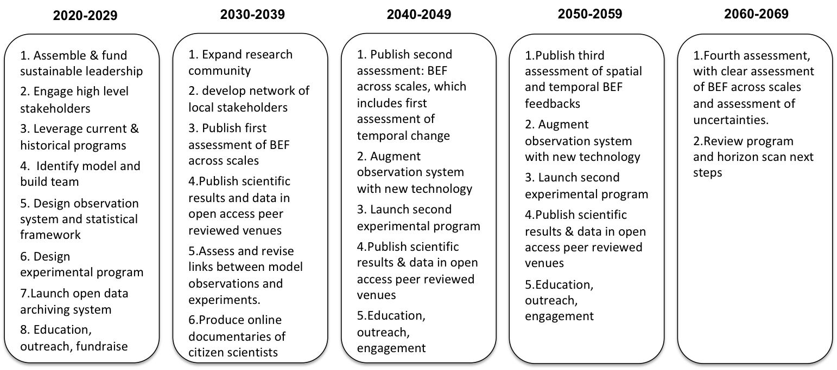

Figure 2. That includes scales from plot to globe / space and time; and illustrates relationships between biodiversity and function, and knowledge gaps and needs; illustrate multiple types of diversity measurable at multiple scales; same for functions. Visualizing interactions. Direct and indirect feedbacks between b and f, and indirect effects of drivers on bef. And human feedbacks. (use UN icons for different services and functions; function / services / human well-being icons, like in IPCC).

Other possible figures.

An assessment of biodiversity now and BEF - current IPBES report.

Figure that includes an illustration of stratified random sampling; open access science.

Figure with people observing, including technology, citizen science, kid in front of a school. 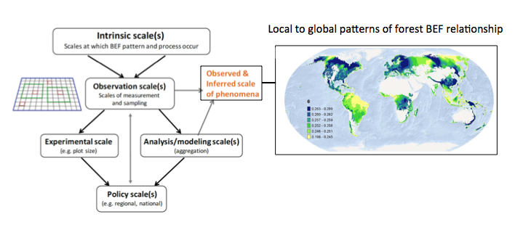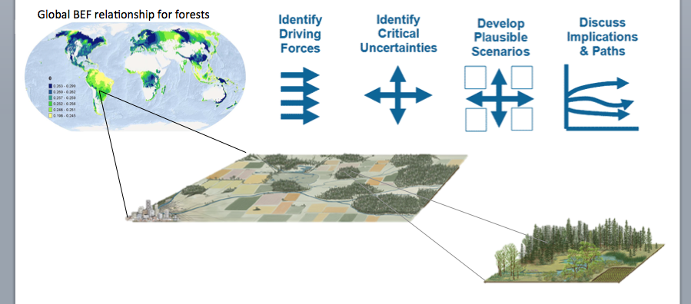
Notes from discussion on Feb 9, 2018, in Santa Barbara:

What do we want to know?
Yann and Laura W:
- B, EF, or both?
- Because we know there is a relationship between BEF at local scales, we need to understand how that translates to other scales.
- Even if we don’t know that we have to understand how diversity is being lost; identify drivers of change in diversity and the processes that mediate.
- Identify a ‘minimally functioning’ earth, and how many species we need.

Sasha and Forest:
- Fine scale global productivity information (high freq S-T lidar)
- Genetic and species diversity from meter to global scale (genetic barcoding and hyperspectral reflectance)
- Dispersal rate for all species
- C, N and Water cycles resolved for all scales
- Watts at all scales
- Realized speciation rates for all taxa
- Food web relationships at all scales
- Dominant coexistence mechanisms, and variation in these.

Laura D and Jane:
- Build predictive, mechanistic models
- Build / understand links between management decisions and drivers to biodiversity and ecosystem function to understand mechanisms.
- Global database of management decisions and drivers
- Hyperspectral daily high resolution data
- Promising that if we make investments in nature, we will get benefits, but we don’t know how policies and drivers will lead to these outcomes - we don’t know the where and when.
- Build a training set of observations for testing hypotheses or road testing predictions (validating the model)
- Visualize, model biodiveristy change in the absence of humans (the world without humans as a reference state for biodiversity change).
- Critically assess contribution of biodiversity to function in these more complex models
- Develop a model for understanding how to use eDNA to understand BEF?

Jarrett and Tim:
- We must be able to link changes in biodiv to changes in function over 50 years (now to the future). We need to be able to assess whether change in biodiversity that has by then happened, has been consequential.
- We need to understand the distribution of change in many different ecosystem functions, and also the relationship between bef, in different systems and for different functions.
- Understand how landscape scale biodiversity supports ecosystem function.
- We need to understand how to decouple signals of change in space and time.

Patrick and Akira
- What is the current state of biodiversity and ecosystem function
- Is it changing?
- How is it changing?
- Data that is representative of teh globe, ecosystems and taxonomic groups.
- We need abundance based data (not yet available with eDNA); need multiple approaches for sampling and collecting data.
- Wanted trait data and phylogeny knowledge
- Open data and archiving so that data from all regions is available and accessible. Overcoming infrastructure and language barriers.

Michel
- Most of what we are doing currently will not be relevant in 50 years. We will then have good knowledge of the arrows in the FW, but we will think of new arrows.
- The feedback effects in the FW will become more important to how we leverage science to make decisions… and how the socio-ecological systems works.
- We will need to know about the feedbacks, and the change in them, in the feedbacks between human systems and biodiversity adn ecosystem functioning.
- We will need data on humans, where they are, what they are doing, how they change the ecosystems, etc. these must be coupled to biodiversity data.

Andy - G
- BEF as a relational network problem of diverse behaviours/activity driving fluxes of energy and matter.
- How can we steer the feedbacks/feedforward behaviours?
- Can we align different reserach agendas currently proposed to address ecosystem degradation.

Peter
- What is it that we need to know the most?
- What are the strongest drivers on humans, biodiversity and ef? What is the uncertainty on these knowledge? (analogy to the climate forcing models)

Yann

Synthesis of what we want to know:

- Serious sampling of the planet: biodiv, ef, and human activities and interactions with BEF
- Better model of how biodiv, EF and human activities are related across scales of space and time that allows us to use observations and that guides experiments.
- Accessible information and data
- ...

How do we get there?
Training
Education so that people understand biodiversity and ecosystem functioning.
Centralized data and information
Global or local funding streams

Yann, Laura and Sasha, and Forest:
- Sampling methods that are standard, accessible and cheap, like the Tea Bag Index (TBI)
- Active participation; guided participation so that it fits a carefully considered sampling design.
- Partner with larger organizations or parties that have access to information that is otherwise difficult to option; involve social, economic, political institutions in observing (e.g., military). For example, from Jarrett’s group, corporate insurers.

Jarrett, Tim, Laura and Jane
- Partner with organizations that will need data such as insurers.
- Grid the earth: stratified random sampling design using common protocols within ecoregions
- Build a open database of natural experiments (and other associated data for attribution)

Andy, Akira and Patrick
- We should do a budget. What is the value added in a new framework. We could look back at last 30 years and look at knowledge gained from past funds. Use existing programs (e.g., quebec) as model. Identify mismatches between what is needed and what is supported.
- Data half life is small, so archiving and curating data
- Equity among data producers and users must be guaranteed
- Who should do it - maybe not academics in universities. Maybe something more like USGS, housing a professional research community working on this as their full time job. They are distributed globally, and not clustered in wealthy, stable countries.
- We need data standards (EBVs, better EBVs for biodiv), and link them to the costs.
- Integrate data collection with education via schools and young students.

Michel, Peter, Mary
- Develop a strong leadership group that is well organized, and primarily scientific. Allow it 5-10 years and support the leadership financially so they have stability in their leadership. And support for coordination.
- Have a clear message so that when people/governments, etc/ listen to this group, the message for action is clear (protocols, sampling design, etc)
- Engage with the public early to have support and participation in the data collection and understanding gained.

Akira:
From the beginning and in the leadership, have engagement from non-european/non-us scientists and countries; also have a process to integrate indiginous knowledge.

While you’re counting the books in your library, your library is burning. Meaning, we can’t wait for certainty at the global scale to use this information for decision making.

Notes from Mary and Andy’s discussions and preparation, before the group discussion:
Perhaps we are proposing to build a better earth observing system, designed around BEF.

Domain of this agenda: biodiversity change and its ecosystem consequences

Hooks:
- Data is not fit for purpose. We need a solution:
- New model for earth system
- Planetary boundaries fw - missing everything in between
- Observation / missing observations

What do want to know:
- How biodiversity has changed over time at across ‘scales’ of observation
- What is the sign and magnitude BEF relationship at spatial and temporal ‘scales’ relevant to decision making.

Agenda (how to get there):

- Steering committee
- Multi-scale model of the biosphere for decision making (something like the maddingly model); it can help estimate what has happened in recent decades, and forecast future patterns.
- Observing biodiversity and function change together at different spatial scale. Use existing observatory plans - GeoBon: legitimate process. But unfunded. To continuously feed this process. We’re proposing these be augmented now to reflect the knowledge we now have about BEF and to fill gaps.
- Experiments linked to observatories that provide information for the model to help with understanding and projection.

----
Be able to relate the observations we make in these highly observed areas to other scales that are relevant to policy making; and functions that occur at other scales. This comes from a better model of scaling BEF… which comes from...

Ideas about figures:

Boxes for each decades and what we should be accomplishing; milestones on the agenda. Assessments.

Figure that includes scales from plot to globe / space and time; and illustrates relationships between biodiversity and function, and knowledge gaps and needs; illustrate multiple types of diversity measurable at multiple scales; same for functions. Visualizing interactions. Direct and indirect feedbacks between b and f, and indirect effects of drivers on bef. And human feedbacks. (use UN icons for different services and functions; function / services / human well-being icons, like in IPCC).

An assessment of biodiversity now and BEF - current IPBES report.

Figure that includes an illustration of stratified random sampling; open access science.

Figure with people observing, including technology, citizen science, kid in front of a school.

Relevant papers:
http://www.cell.com/trends/ecology-evolution/abstract/S0169-5347(17)30060-5

Pettorelli, N., Owen, H.J.F. & Duncan, C. (2016) "How do we want Satellite Remote Sensing to support biodiversity conservation globally?". Methods in Ecology and Evolution -- http://onlinelibrary.wiley.com/doi/10.1111/2041-210X.12545/full

Pettorelli, N., Wegmann, M., Skidmore, A., Mücher, S., Dawson, T.P., Fernandez, M., Lucas, R., Schaepman, M.E., Wang, T., O’Connor, B., Jongman, R.H.G., Kempeneers, P., Sonnenschein, R., Leidner, A.K., Böhm, M., He, K.S., Nagendra, H., Dubois, G., Fatoyinbo, T., Hansen, M.C., Paganini, M., de Klerk, H.M., Asner, G.P., Kerr, J., Estes, A.B., Schmeller, D.S., Heiden, U., Rocchini, D., Pereira, H.M., Turak, E., Fernandez, N., Lausch, A., Cho, M.A., Alcaraz-Segura, D., McGeoch, M.A., Turner, W., Mueller, A., St-Louis, V., Penner, J., Vihervaara, P., Belward, A., Reyers, B. & Geller, G.N. (2016) "Framing the concept of Satellite Remote Sensing Essential Biodiversity variables: challenges and future directions." Remote Sensing in Ecology and Conservation. -
https://research.utwente.nl/en/publications/framing-the-concept-of-satellite-remote-sensing-essential-biodive

